Contents

NOTE 7

Computational Unit Without Decoder 9

Gate Level Drawing 9

Schematic 9

Symbol 10

Test case 11

Waveform 11

Calculation 11

Conclusion 12

Computational unit with decoder 12

Gate level drawing 12

Schematic 12

Symbol 13

Test case 14

Waveform 14

Calculation 14

Conclusion 15

CU WITH DECODER AND ENABLE 15

Gate level drawing 15

Schematic 15

Symbol 16

Test 16

Waveform 17

Calculations 17

Conclusion 17

Overall Design(OVERALL DEVICE) 18

Gate level drawing 18

Schematic 18

Symbol 19

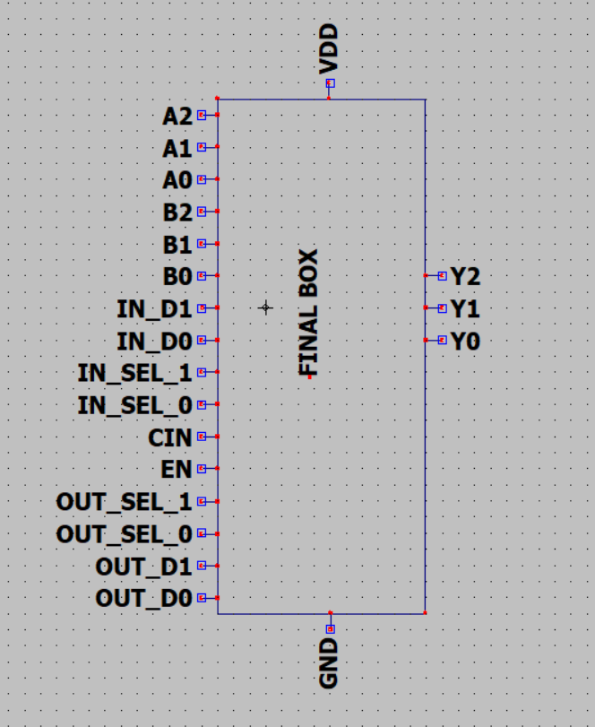 19

Test case 20

Waveform 20

Calculations 20

Conclusion 21

Operation component 21

3 Bit Full Adder Without Enable. 21

Gate level drawing 21

Schematic 21

Symbol 22

Test case 23

Waveform 23

Calculations 23

Conclusion 23

3 Bit full Adder With Enable. 24

Gate level drawing 24

Schematic 24

Symbol 25

Test 26

Waveform 26

Calculation 26

Conclusion 26

3 Bit Multiplier Without Enable. 27

Gate level drawing 27

Schematic 27

Symbol 28

Test case 29

Waveform 29

Calculation 29

Conclusion 29

3 Bit Multiplier With Enable. 29

Gate level Drawing 30

Schematic 30

Symbol 31

Test case 32

Waveform 32

Calculation 32

Conclusion 33

Greaterthan Circuit Without Enable. 33

Gate level drawing 33

Schematic 33

Symbol 34

Test case 35

Waveform1 35

Calculation1 35

Conclusion 35

Greaterthan Circuit with Enable. 36

Gate Level Drawing 36

Schematic 36

Symbol 37

Test case 38

Waveform 38

Calculation 38

Conclusion 38

Athematic Shift Right Without Enable. 39

Gate Level Drawing 39

Schematic 40

Symbol 42

Test case 43

Waveform 43

Calculation 43

Conclusion 43

Athematic shift right with enable. 44

Gate level drawing 44

Schematic 44

Symbol 45

Test case 46

Waveform1 46

Calculation 46

Conclusion 47

Components 47

2 TO 1 MUX 47

Gate level drawing 47

Schematic 47

Symbol 48

Test 48

Waveform 49

Calculations/Truth table 49

Conclusion 49

4 TO 1 MUX 50

Gate level drawing 50

Schematic 50

Symbol 51

Test 52

Waveform 52

Calculations/Truth table 52

Conclusion 53

8 TO 1 MUX 53

Gate level drawing 53

Schematic 53

Symbol 54

Test 55

Waveform 55

Calculations/Truth table 55

Conclusion 56

Half adder 56

Gate level drawing 56

Schematic 56

Symbol 57

Test 57

Waveform 58

Calculations/Truth table 58

Conclusion 58

Full adder 59

Gate level drawing 59

Schematic 59

Symbol 60

Test 60

Waveform 61

Calculations/Truth table 61

Conclusion 61

1 TO 2 DECODER 62

Gate level drawing 62

Schematic 62

Symbol 63

Test 63

Waveform 64

Calculations/Truth table 64

Conclusion 64

2 TO 4 DECODER 65

Gate level drawing 65

Schematic 65

Symbol 66

Test 67

Waveform 67

Calculations/Truth table 67

Conclusion 67

3 BIT 4 TO 1 MUX 68

Gate level drawing 68

Schematic 68

Symbol 69

Test case 69

Waveform 70

Calculations/Truth table 70

Conclusion 70

# NOTE

1ST TEST CASE IN THE PRESENTATION

IN THE PRESENTATION OUT PUT IS DISPLAYED AS 000 BUT ITS 111 , THE SELECTION OF MUX IS NOT CONNECTED PROPERLLY. I RECTIFIED IT. FOR REFERENCE PLEASE CHECK THE BELOW SCREEN SHOT.

TEST CASE

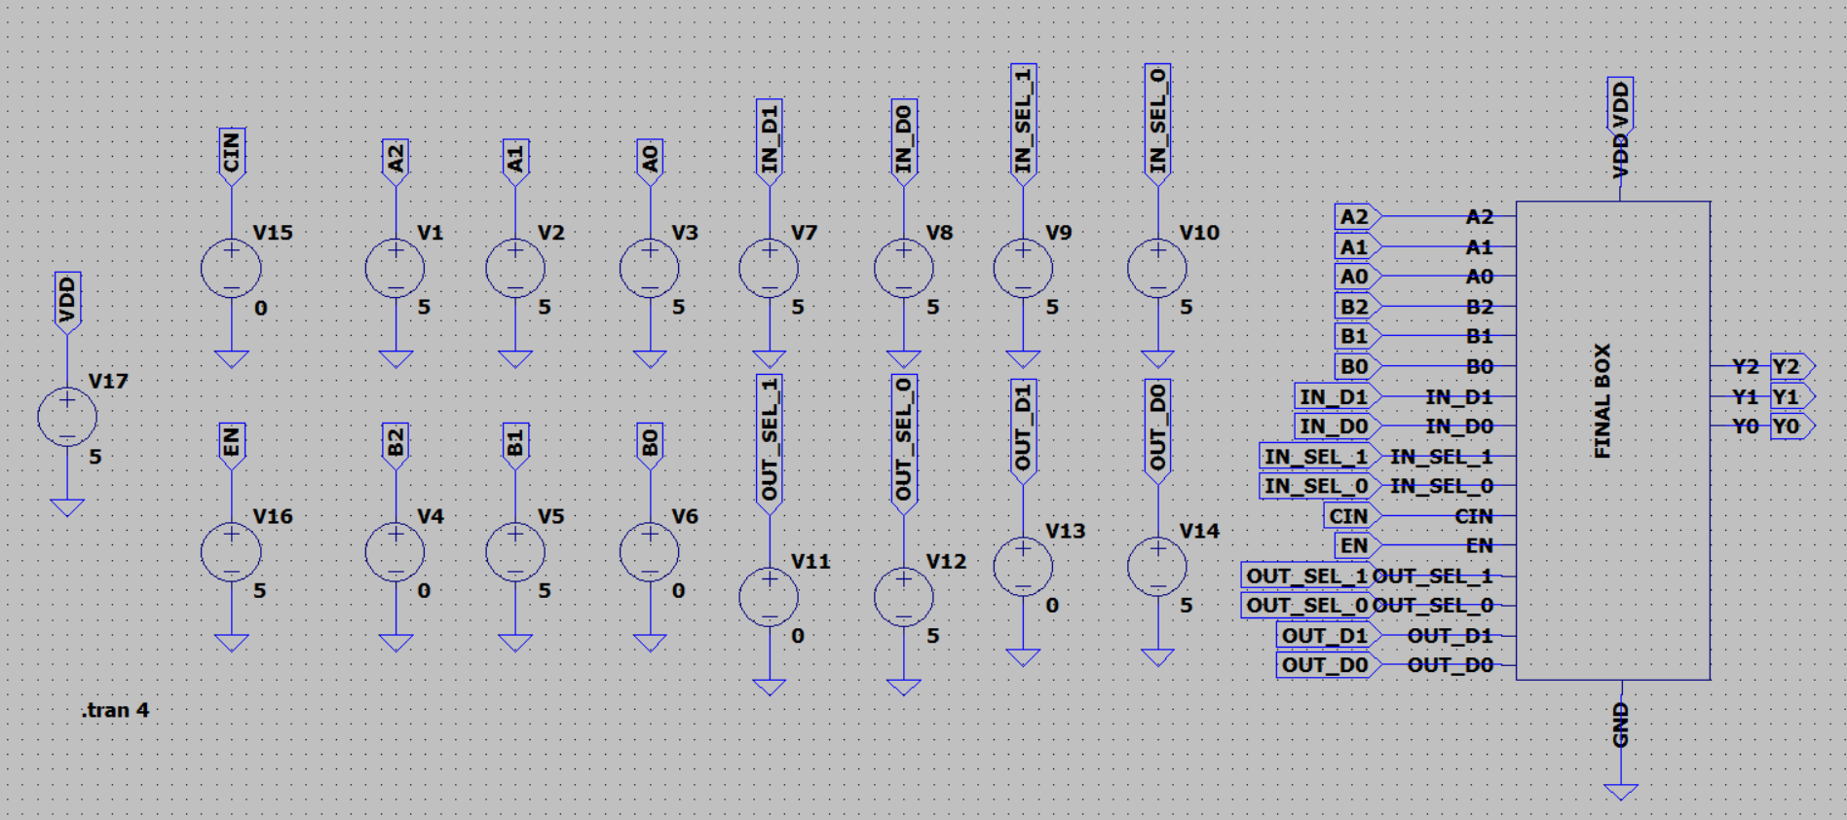

A (-3) = 111

B(2) = 010

CU (2) = 01

OPERATION = ARTHEMATIC SHIFT RIGHT = 11

WAVE FORM

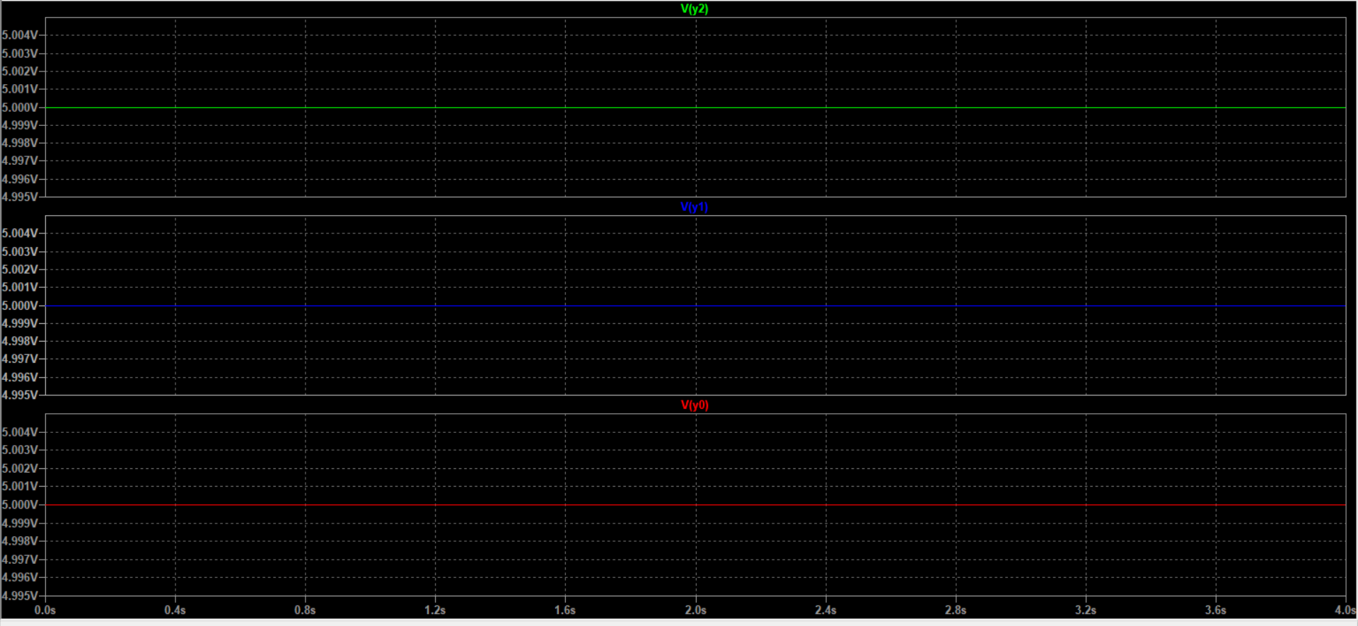

CALCULATION

A (-3) = 111

B(2) = 010

CU (2) = 01

OPERATION = ARTHEMATIC SHIFT RIGHT = 11

OUT PUT = 111

# Computational Unit Without Decoder

## Gate Level Drawing

## Schematic

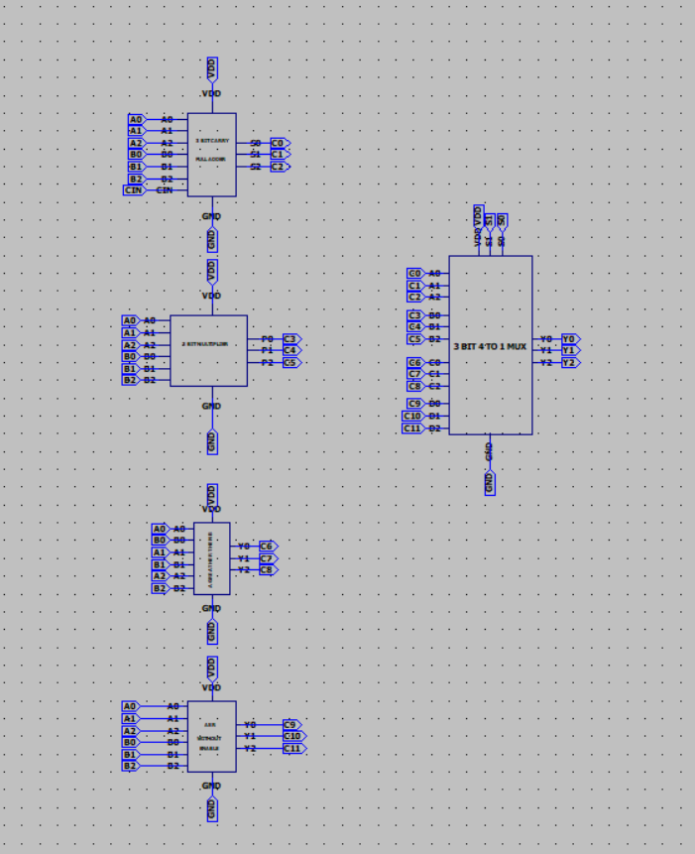

## Symbol

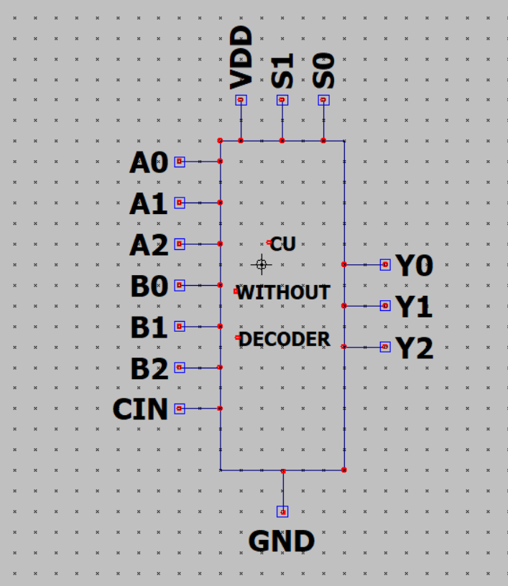

## Test case

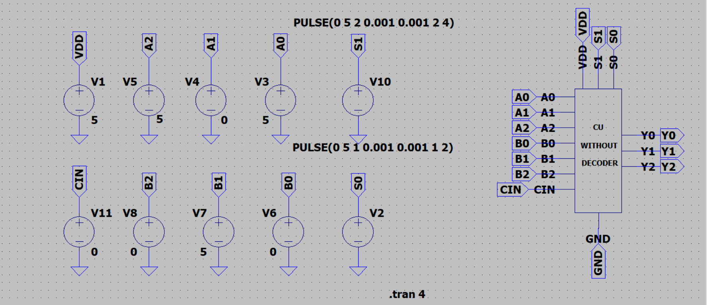

A = 101 B = 010

## Waveform

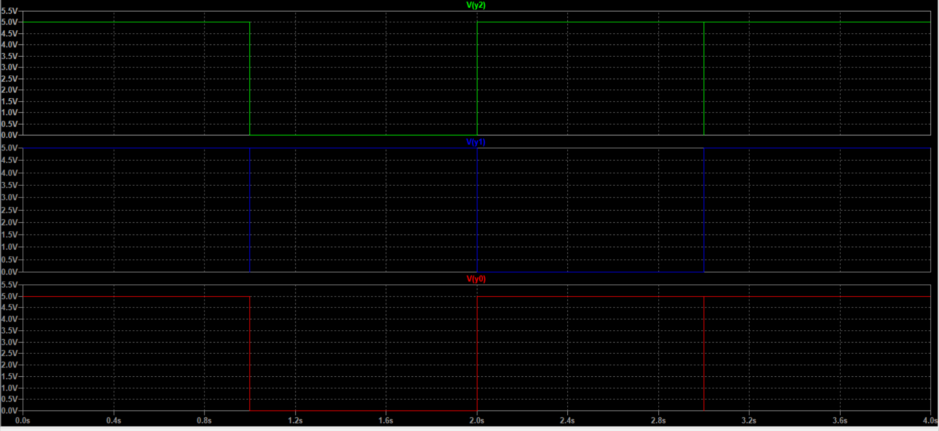

## Calculation

|  |  |  |  |  |  |  |  |
| --- | --- | --- | --- | --- | --- | --- | --- |
| **S.NO** | **A** | **B** | **CIN** | **S1** | **S0** | **Operation** | **Output (Y)** |
| **1** | **101** | **010** | **0** | **0** | **0** | **ADD** | **111** |
| **2** | **101** | **010** | **0** | **0** | **1** | **MUL** | **010** |
| **3** | **101** | **010** | **0** | **1** | **0** | **GT** | **101** |
| **4** | **101** | **010** | **0** | **1** | **1** | **ASR** | **111** |

## Conclusion

The Operation are working for the selection line and the output is perfectly matching with exact selection of operation from the truth table output and waveforms. So, the circuit is verified.

# Computational unit with decoder

## Gate level drawing

## Schematic

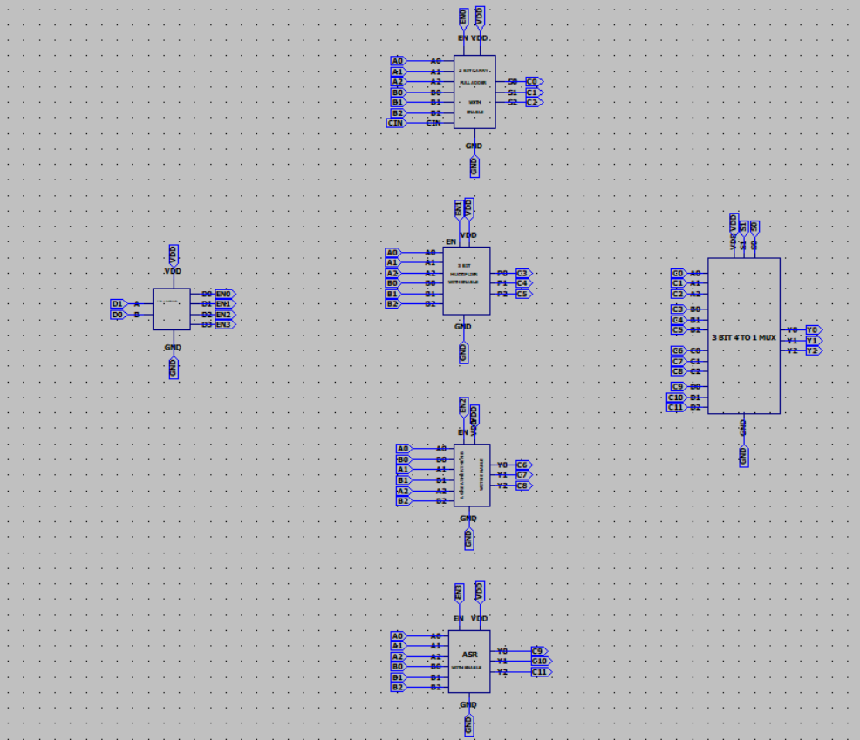

## Symbol

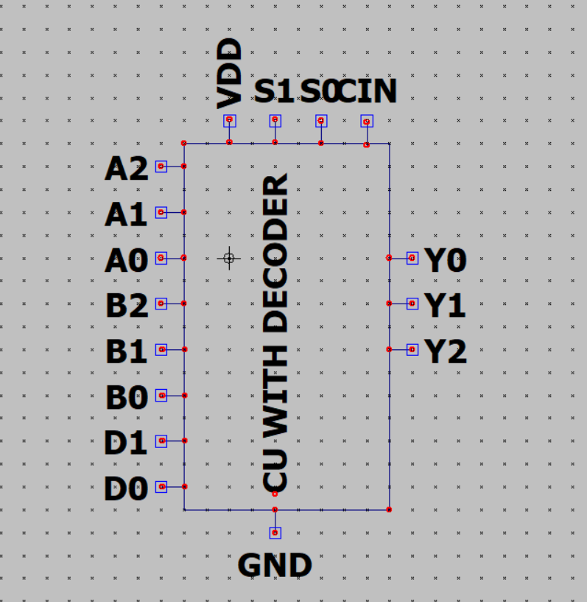

## Test case

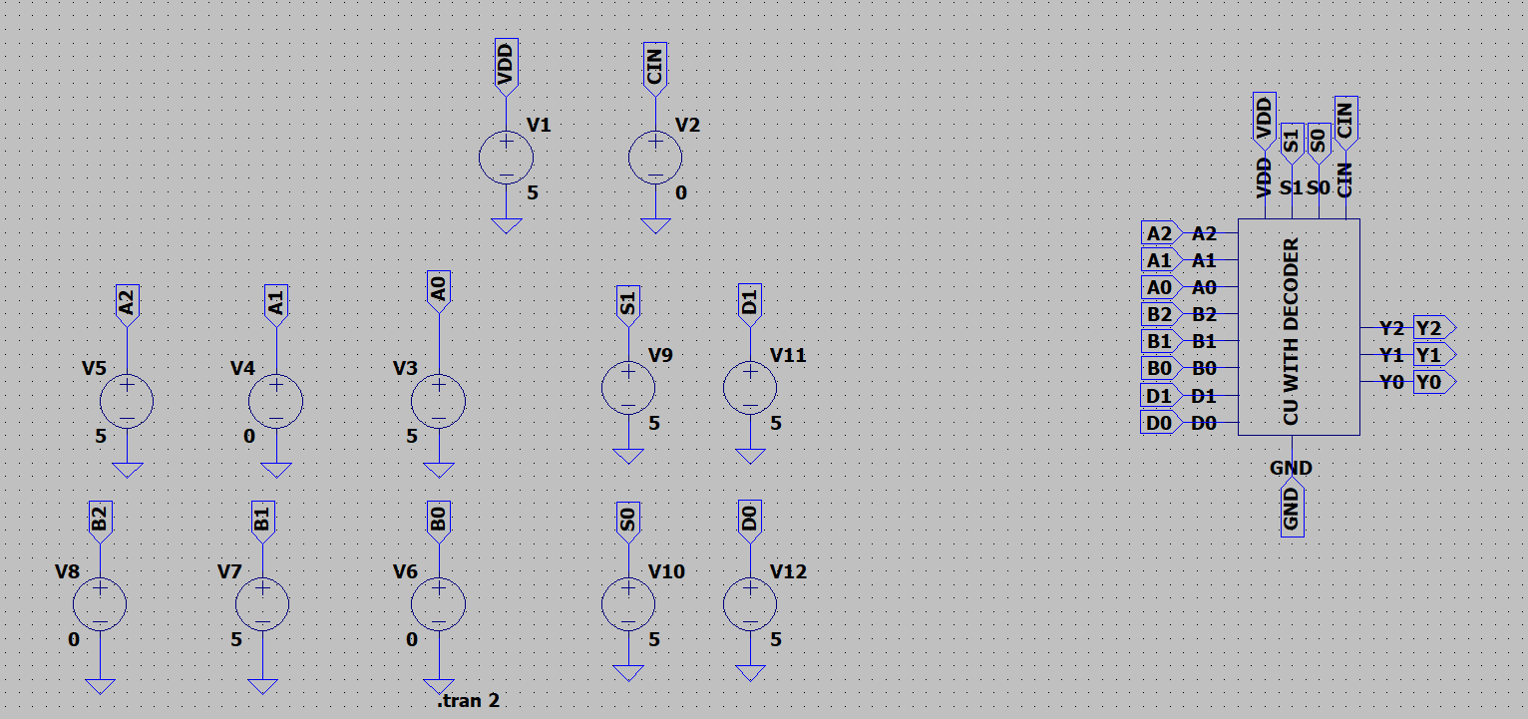

A = 101 B = 010

## Waveform

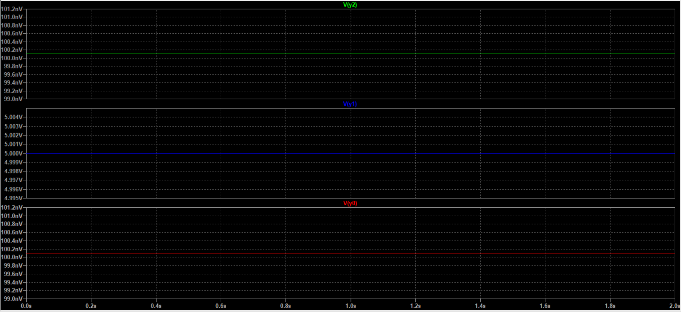

## Calculation

|  |  |  |  |  |  |  |  |  |
| --- | --- | --- | --- | --- | --- | --- | --- | --- |
|  | **INPUT** | | **DECODER** | | **MUX SELECTION** | |  |  |
| **S.NO** | **A** | **B** | **D1** | **D0** | **S1** | **S0** | **Operation** | **Output (Y)** |
| **1** | **101** | **010** | **0** | **0** | **0** | **0** | **ADD** | **111** |
| **2** | **101** | **010** | **0** | **1** | **0** | **1** | **MUL** | **010** |
| **3** | **101** | **010** | **1** | **0** | **1** | **0** | **GT** | **101** |
| **4** | **101** | **010** | **1** | **1** | **1** | **1** | **ASR** | **111** |

## Conclusion

The Operation are working when the decoder giving high value to the enable and the output is coming from the mux using selection lines. The output is perfectly matching with exact selection of operation from the truth table output and waveforms. So, the circuit is verified.

# CU WITH DECODER AND ENABLE

## Gate level drawing

## Schematic

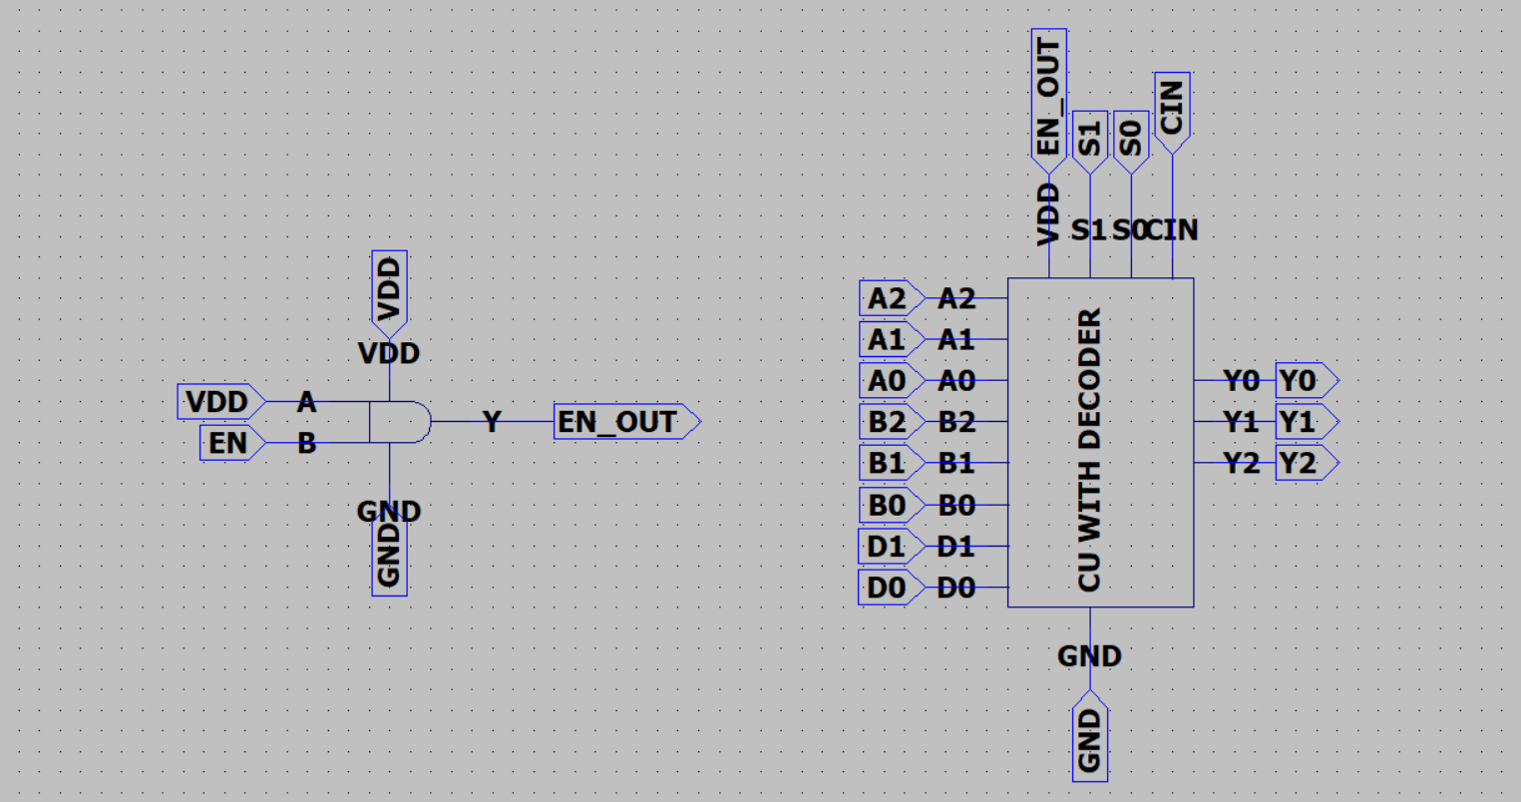

## Symbol

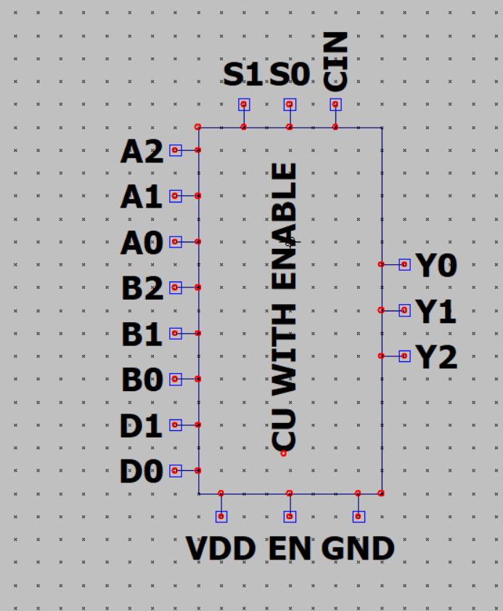

## Test

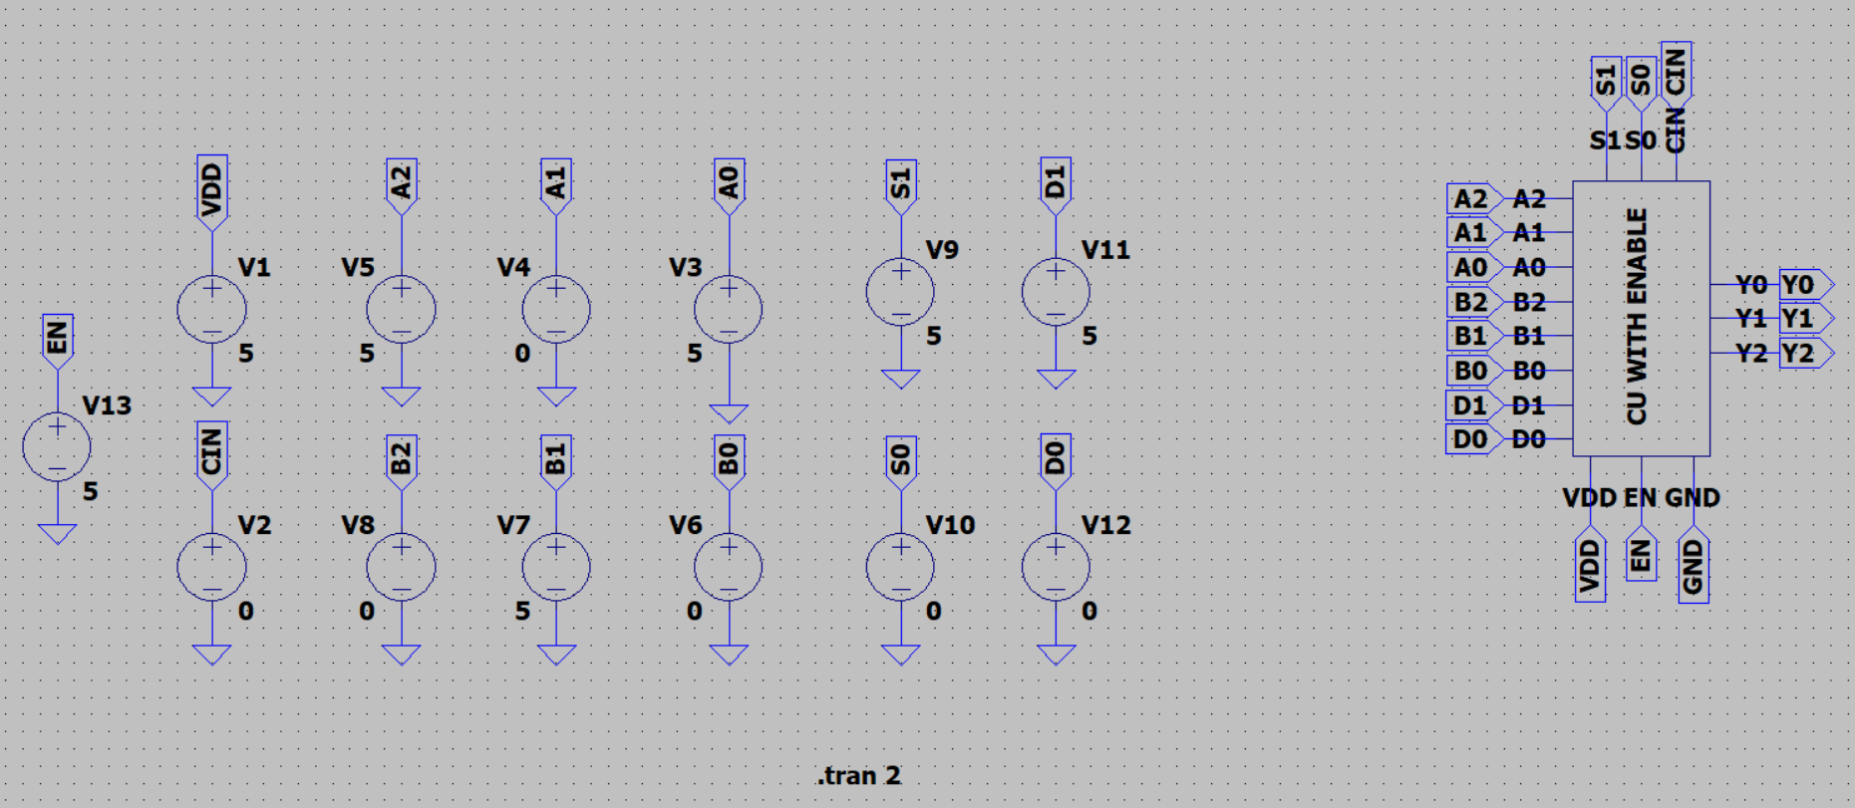

## Waveform

## Calculations

|  |  |  |  |  |  |  |  |  |  |
| --- | --- | --- | --- | --- | --- | --- | --- | --- | --- |
|  |  | **INPUT** | | **DECODER** | | **MUX SELECTION** | |  |  |
| **S.NO** | **EN** | **A** | **B** | **D1** | **D0** | **S1** | **S0** | **Operation** | **Output (Y)** |
| **1** | **0** | **101** | **010** | **1** | **0** | **1** | **0** | **GT** | **000** |
| **2** | **1** | **101** | **010** | **1** | **0** | **1** | **0** | **GT** | **010** |

## Conclusion

The Operation are working when the decoder giving high value to the enable and the output is coming from the mux using selection lines. The output is perfectly matching with exact selection of operation from the truth table output and waveforms. So, the circuit is verified.

# Overall Design(OVERALL DEVICE)

## Gate level drawing

## Schematic

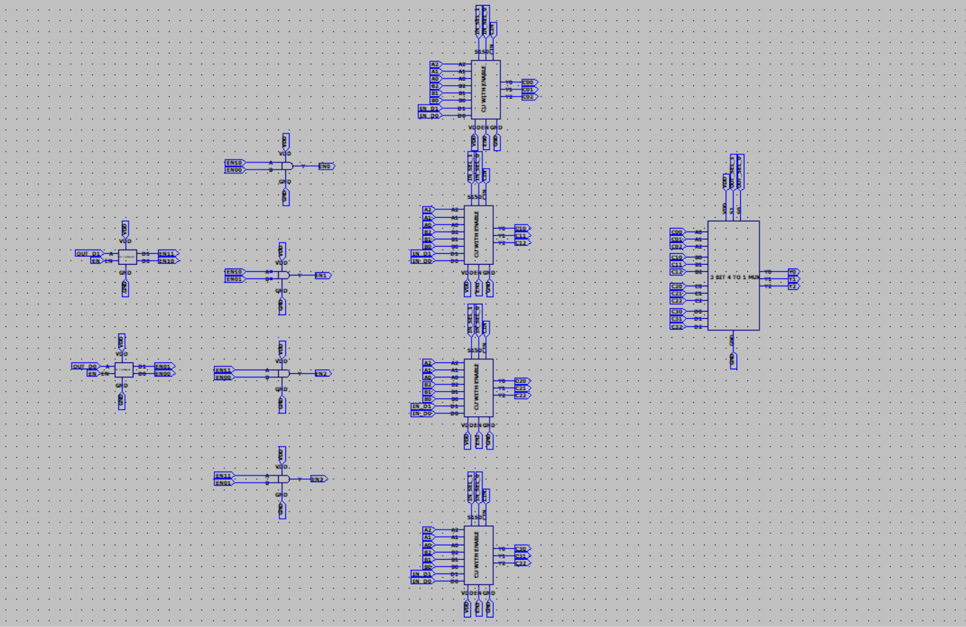

## Symbol



## Test case

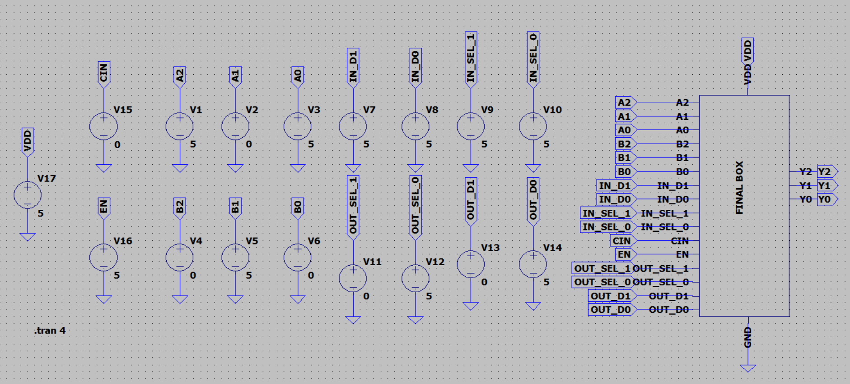

## Waveform

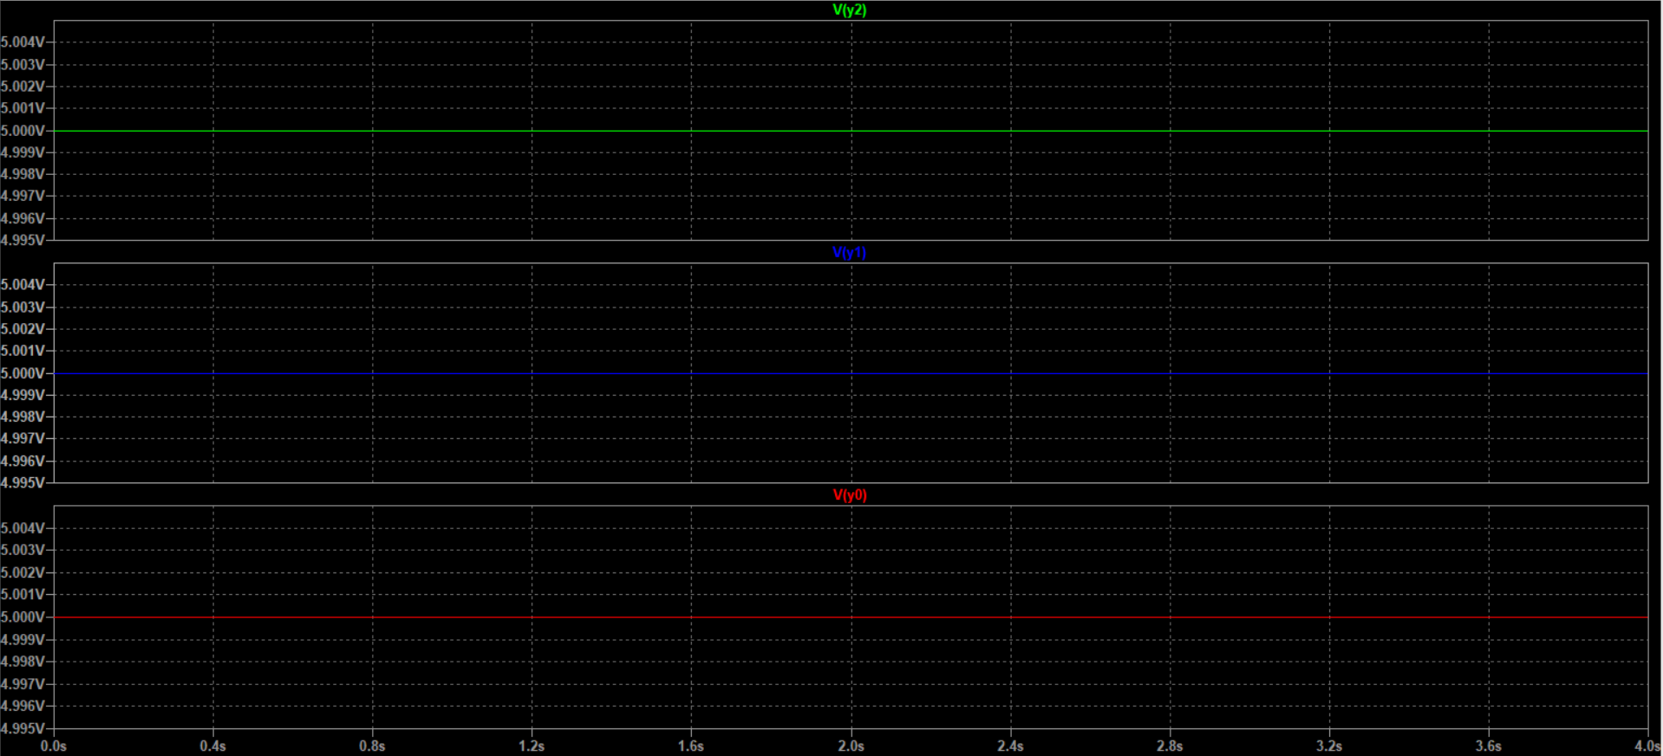

## Calculations

|  |  |  |  |  |  |  |  |  |  |  |  |  |  |
| --- | --- | --- | --- | --- | --- | --- | --- | --- | --- | --- | --- | --- | --- |
|  |  | **INPUT** | | **DECODER IN TOP BOX** | | **MUX SELECTION**  **IN CU** | | **DECODER**  **IN CU** | | **MUX SELECTION IN TOP BOX** | |  |  |
| **S.NO** | **EN** | **A** | **B** | **D11** | **D10** | **SEL1** | **SEL0** | **D1** | **D0** | **S1** | **S0** | **Operation** | **Output (Y)** |
| **1** | **1** | **101** | **010** | **1** | **0** | **1** | **1** | **0** | **1** | **0** | **1** | **asr** | **111** |

## Conclusion

The output is perfectly matching with exact selection of operation from the truth table output and waveforms. So, the circuit is verified

# Operation component

## 3 Bit Full Adder Without Enable.

### Gate level drawing

### Schematic

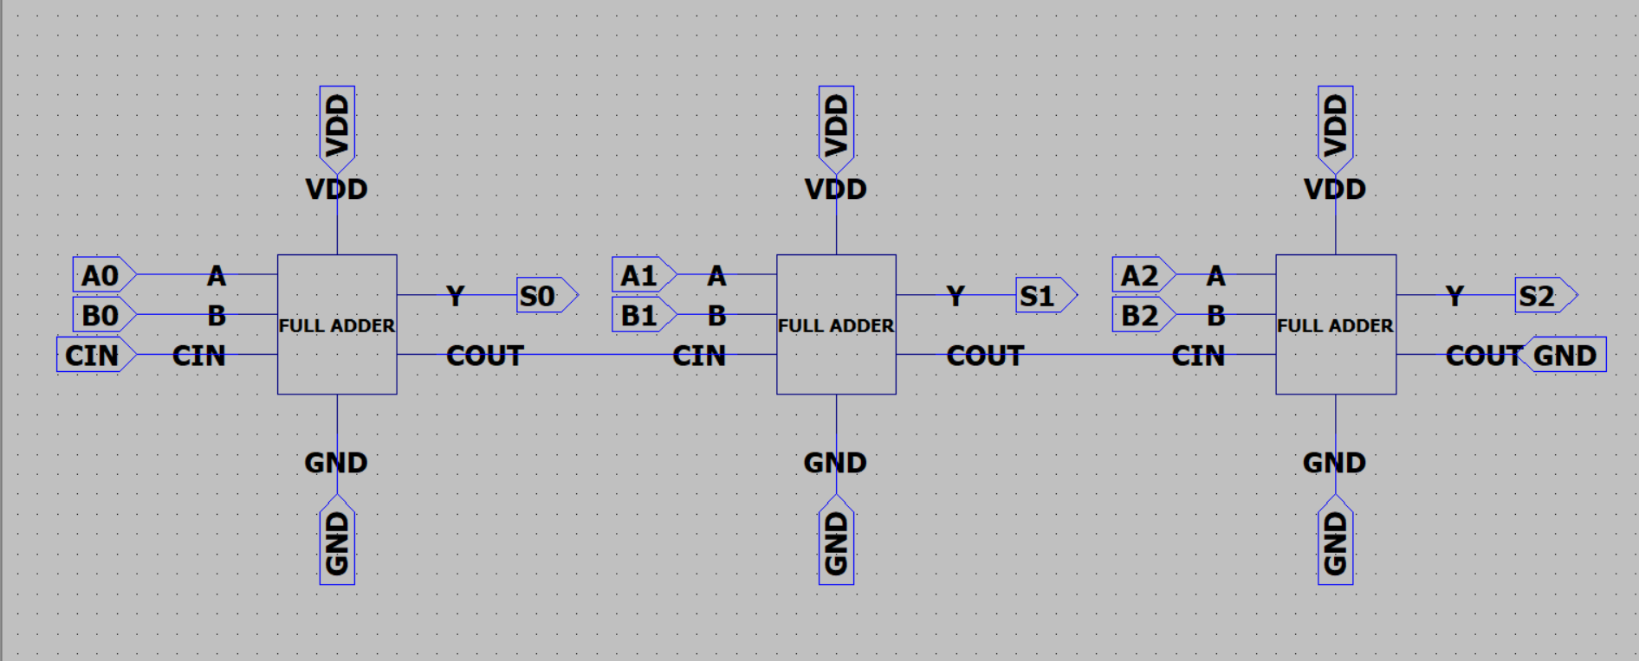

### Symbol

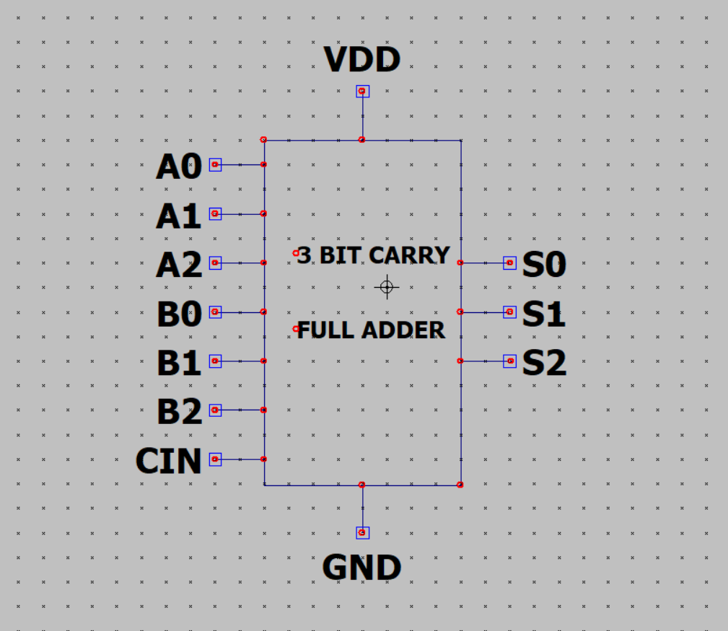

### Test case

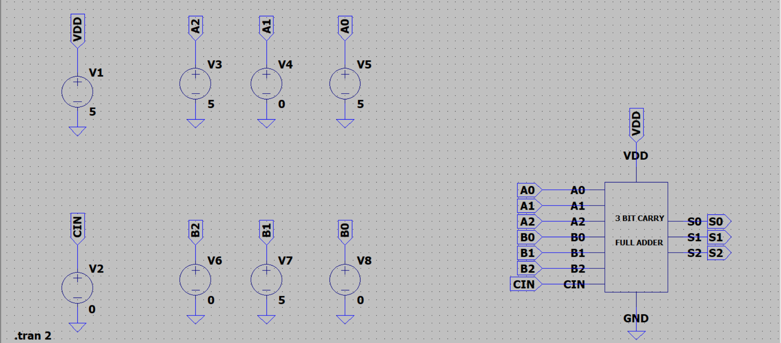

### Waveform

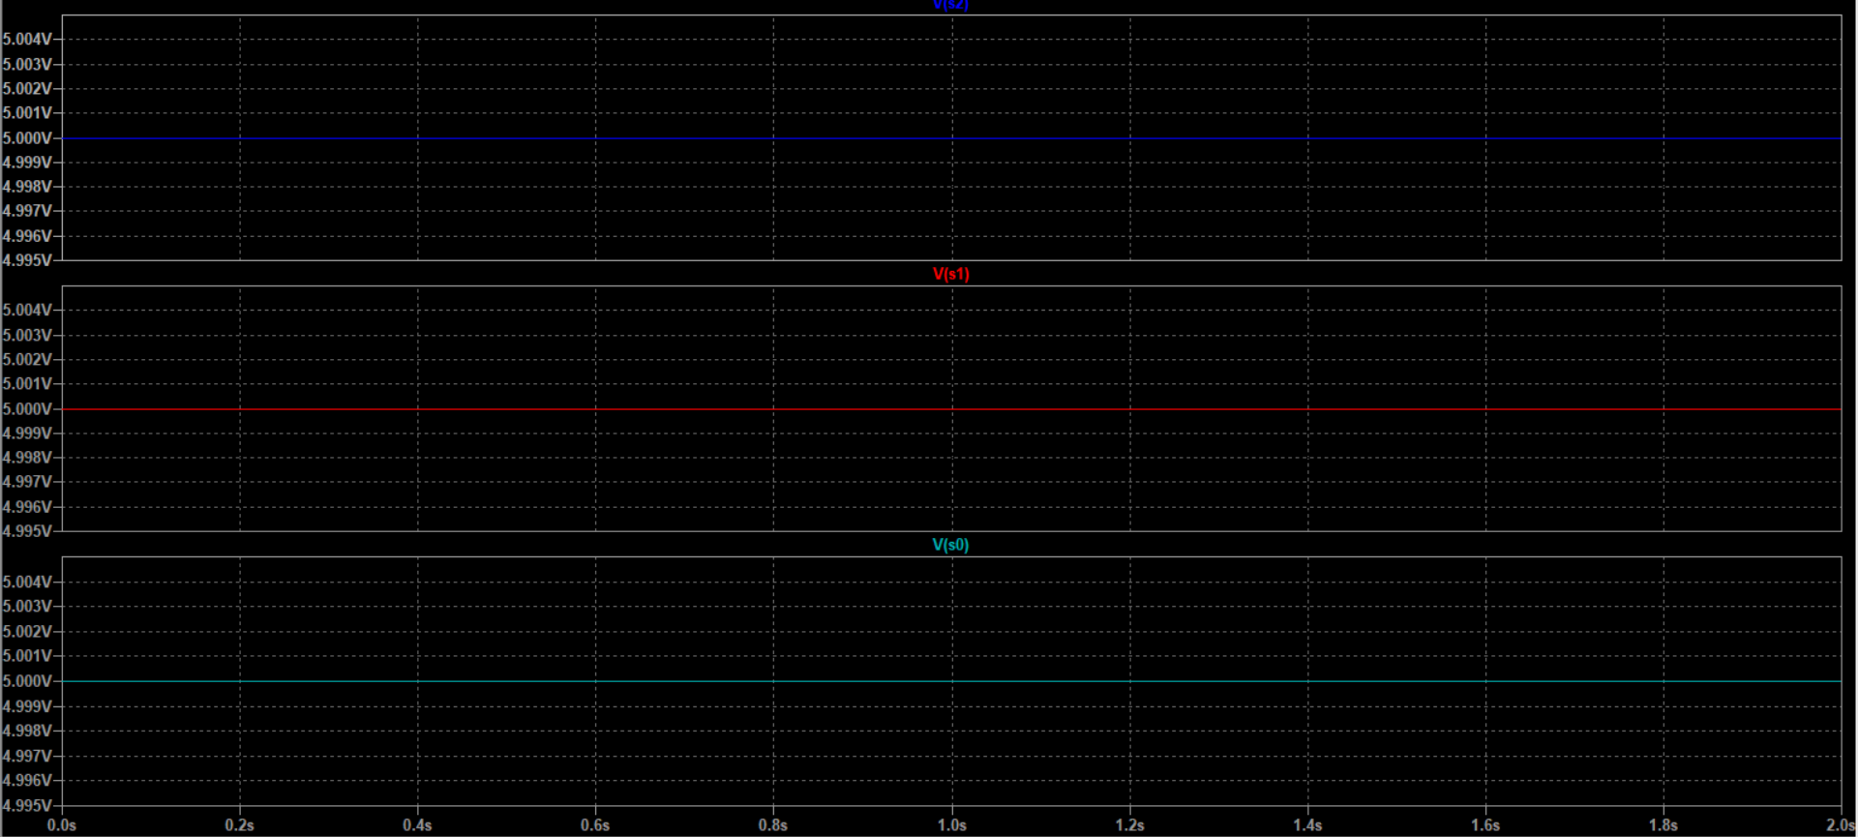

### Calculations

|  |  |  |  |  |  |
| --- | --- | --- | --- | --- | --- |
|  | **INPUT** | | | **OUTPUT** | |
| **S.NO** | **A** | **B** | **CIN** | **COUT** | **Y** |
| **1** | **101** | **010** | **0** | **0** | **111** |

## Conclusion

The output is perfectly matching with exact selection of operation from the truth table output and waveforms. So, the circuit is verified

## 3 Bit full Adder With Enable.

### Gate level drawing

### Schematic

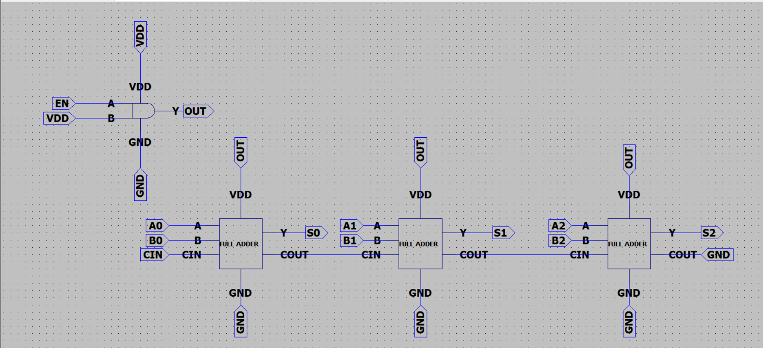

### Symbol

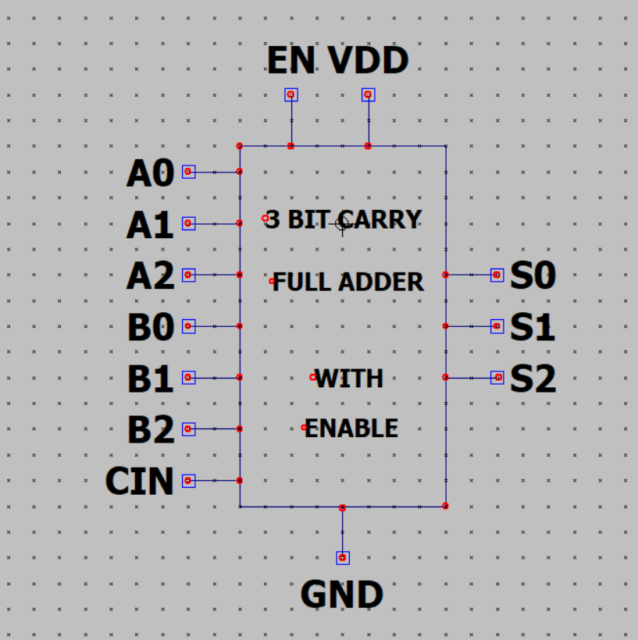

### Test

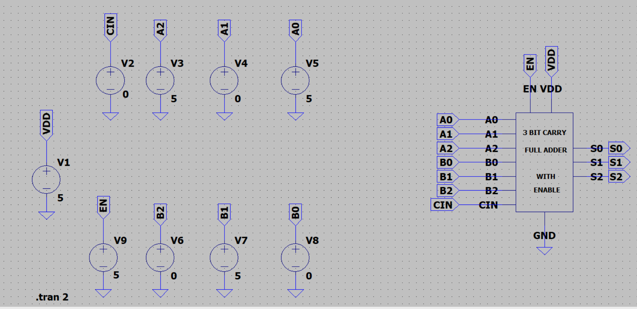

### Waveform

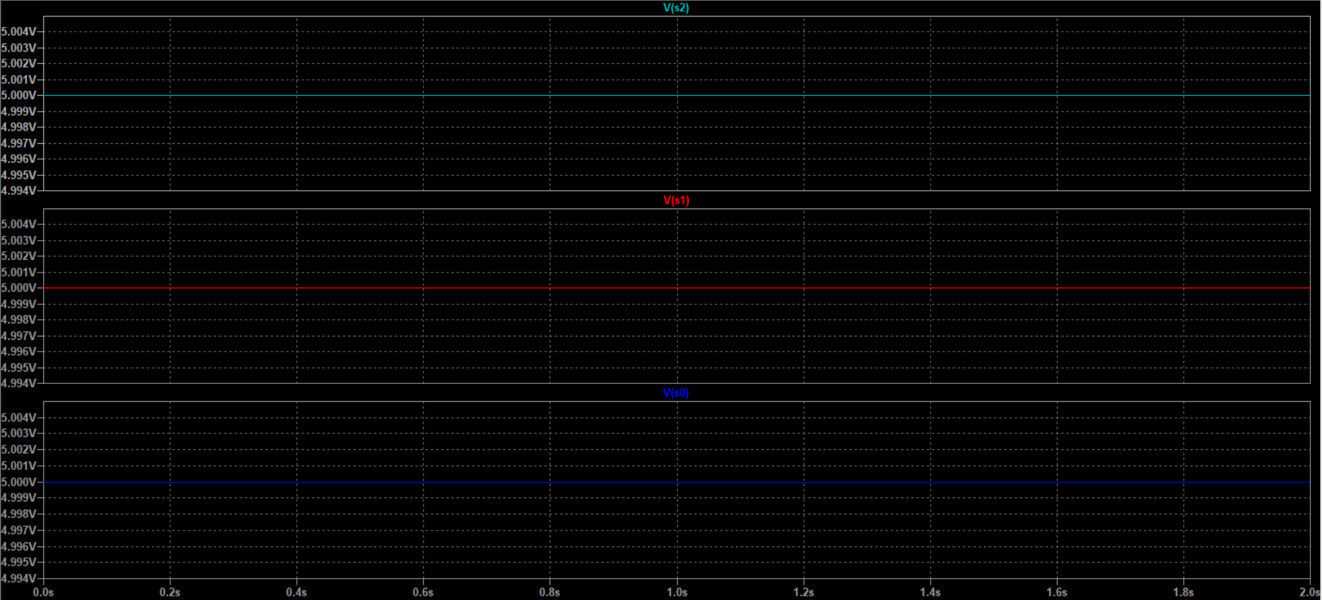

### Calculation

|  |  |  |  |  |  |  |
| --- | --- | --- | --- | --- | --- | --- |
|  |  | **INPUT** | | | **OUTPUT** | |
| **S.NO** | **EN** | **A** | **B** | **CIN** | **COUT** | **Y** |
| **1** | **1** | **101** | **010** | **0** | **0** | **111** |

## Conclusion

The output is perfectly matching with exact selection of operation from the truth table output and waveforms. So, the circuit is verified

## 3 Bit Multiplier Without Enable.

### Gate level drawing

### Schematic

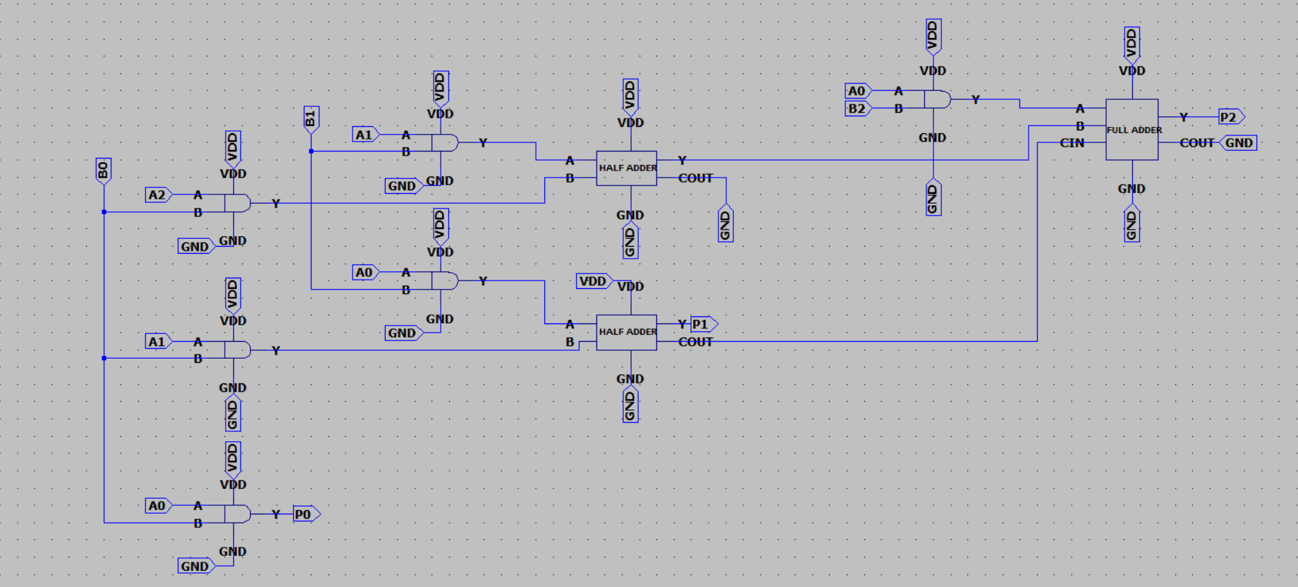

### Symbol

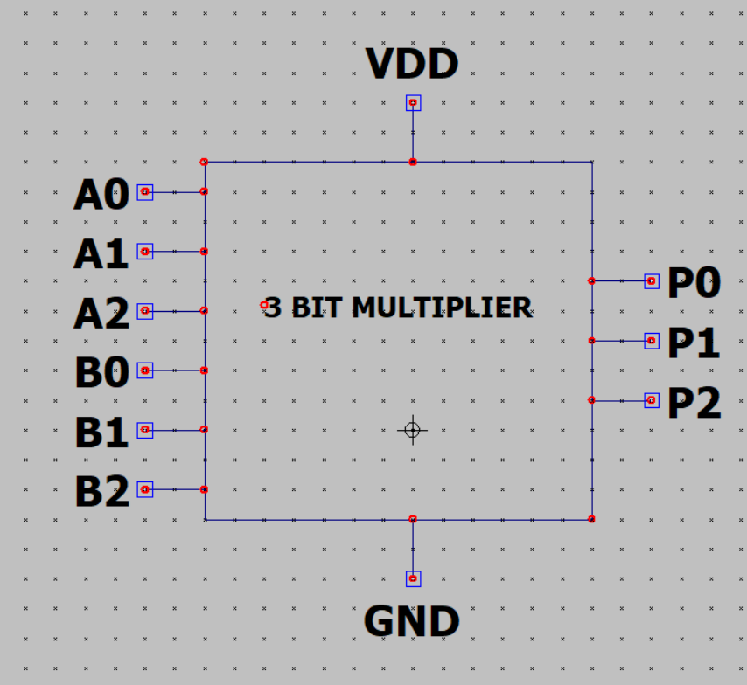

### Test case

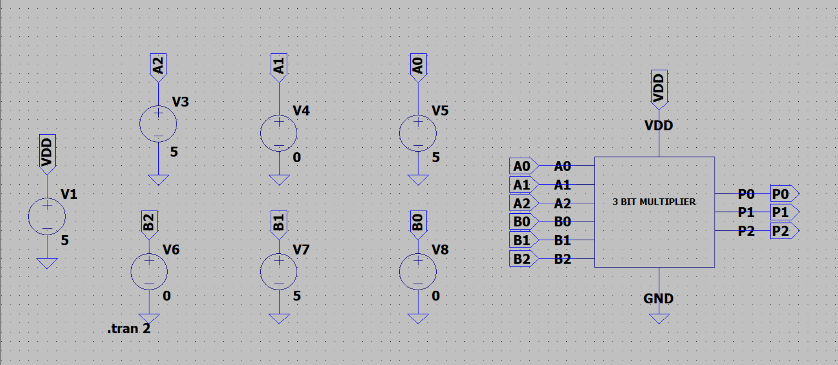

### Waveform

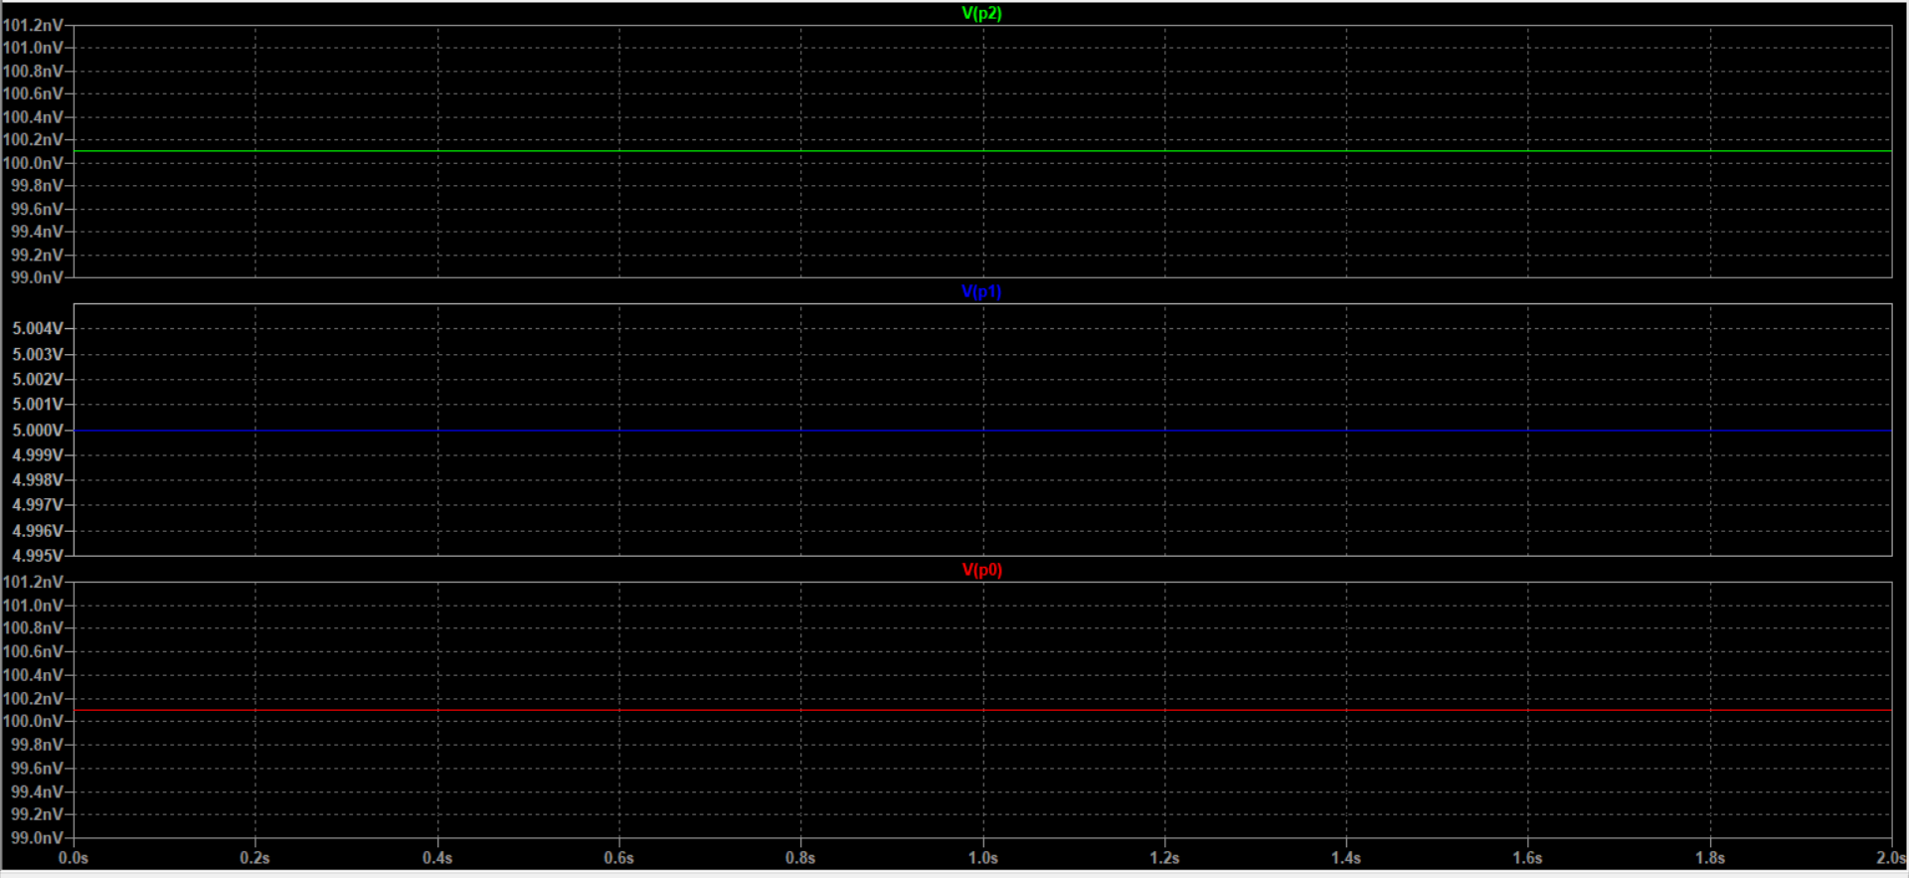

### Calculation

|  |  |  |  |
| --- | --- | --- | --- |
|  | **INPUT** | | **OUTPUT** |
| **S.NO** | **A** | **B** | **Y** |
| **1** | **101** | **010** | **010** |

### Conclusion

The output is perfectly matching with exact selection of operation from the truth table output and waveforms. So, the circuit is verified

## 3 Bit Multiplier With Enable.

### Gate level Drawing

### Schematic

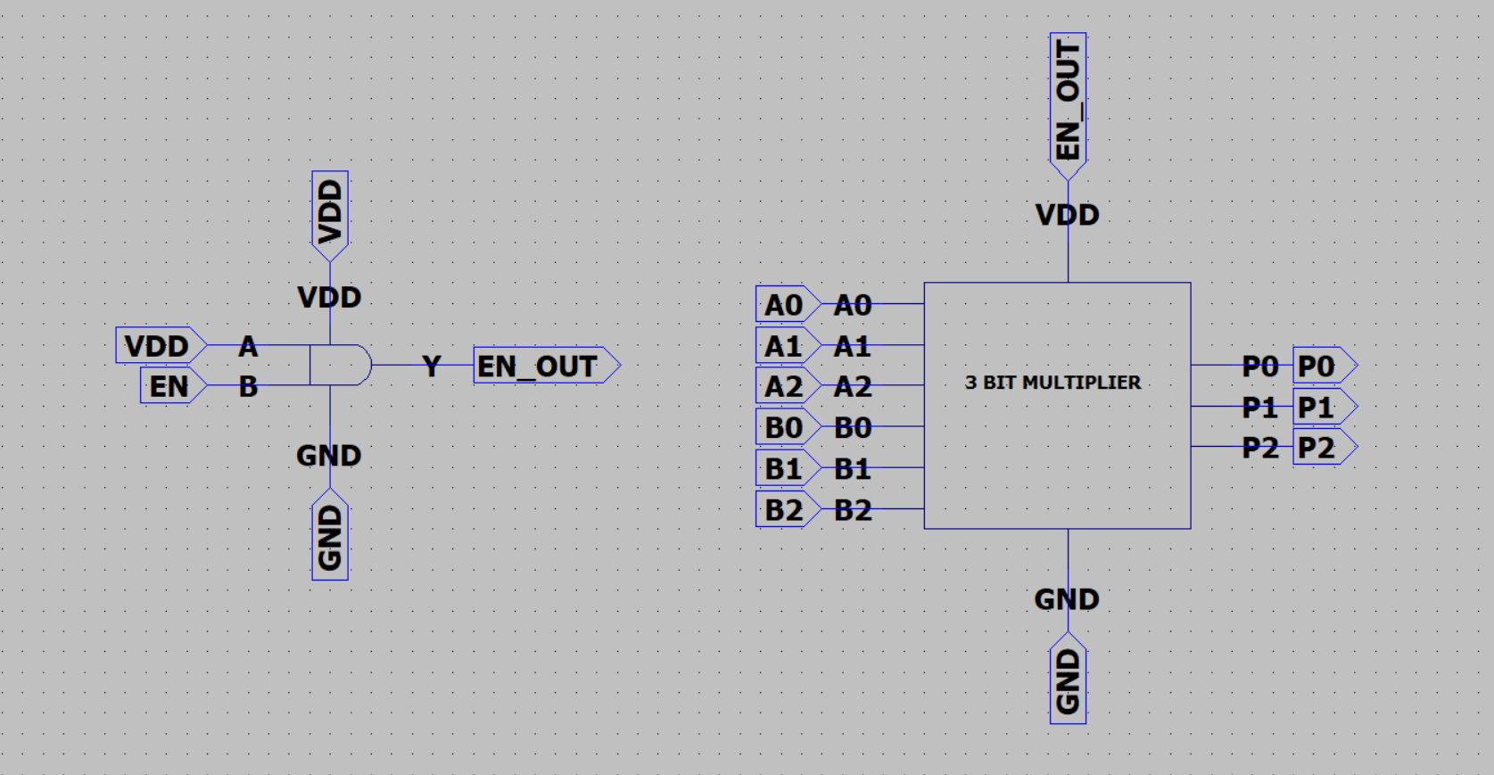

### Symbol

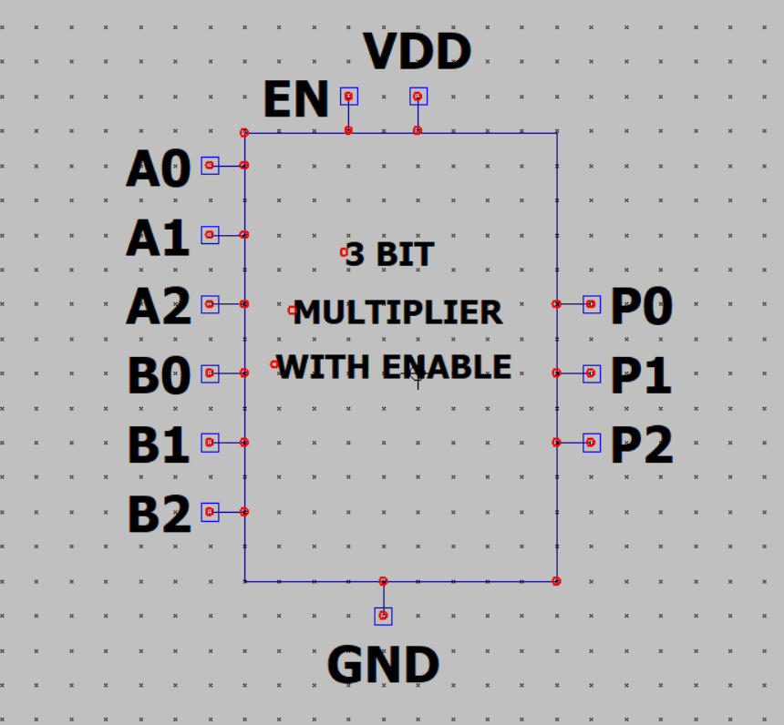

### Test case

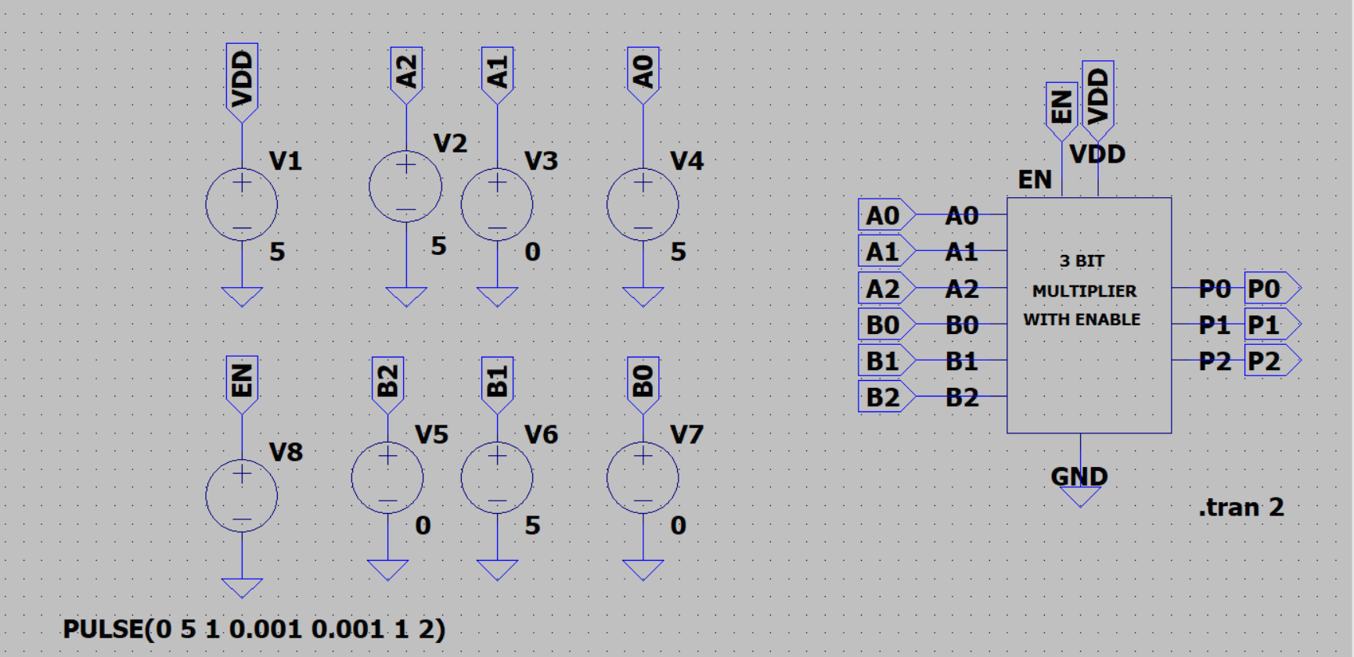

### Waveform

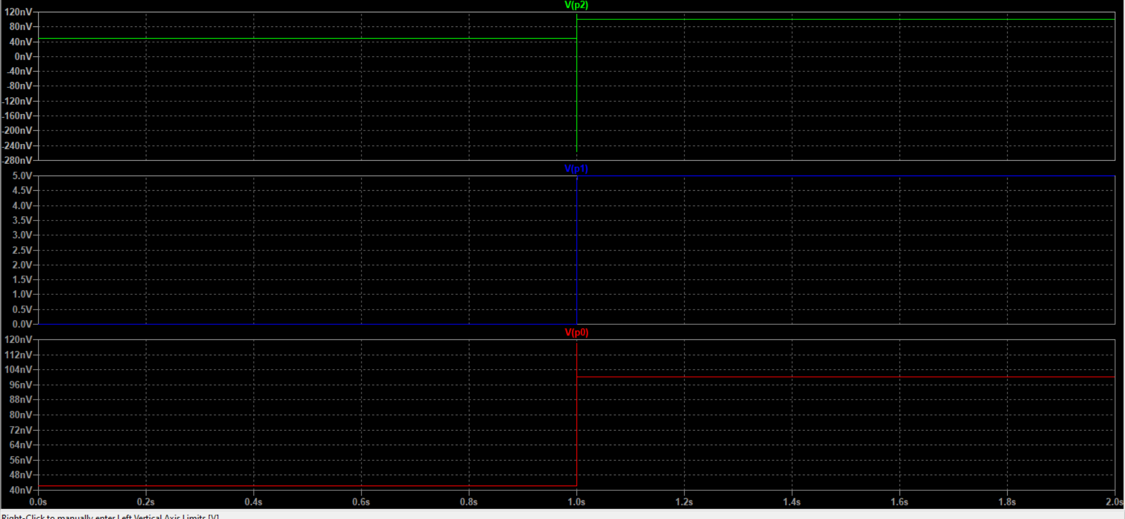

### Calculation

|  |  |  |  |  |  |  |  |  |  |  |  |  |  |  |  |  |  |  |  |  |  |  |  |
| --- | --- | --- | --- | --- | --- | --- | --- | --- | --- | --- | --- | --- | --- | --- | --- | --- | --- | --- | --- | --- | --- | --- | --- |
| |  |  |  |  |  | | --- | --- | --- | --- | --- | |  |  | **INPUT** | | **OUTPUT** | | **S.NO** | **EN** | **A** | **B** | **Y** | | **1** | **1** | **100** | **010** | **010** | | **2** | **0** | **101** | **010** | **000** | |  |  |  |
|  |  |  |  |
|  |  |  |  |
|  |  |  |  |

### Conclusion

The output is perfectly matching with exact selection of operation from the truth table output and waveforms. So, the circuit is verified

## Greaterthan Circuit Without Enable.

### Gate level drawing

### Schematic

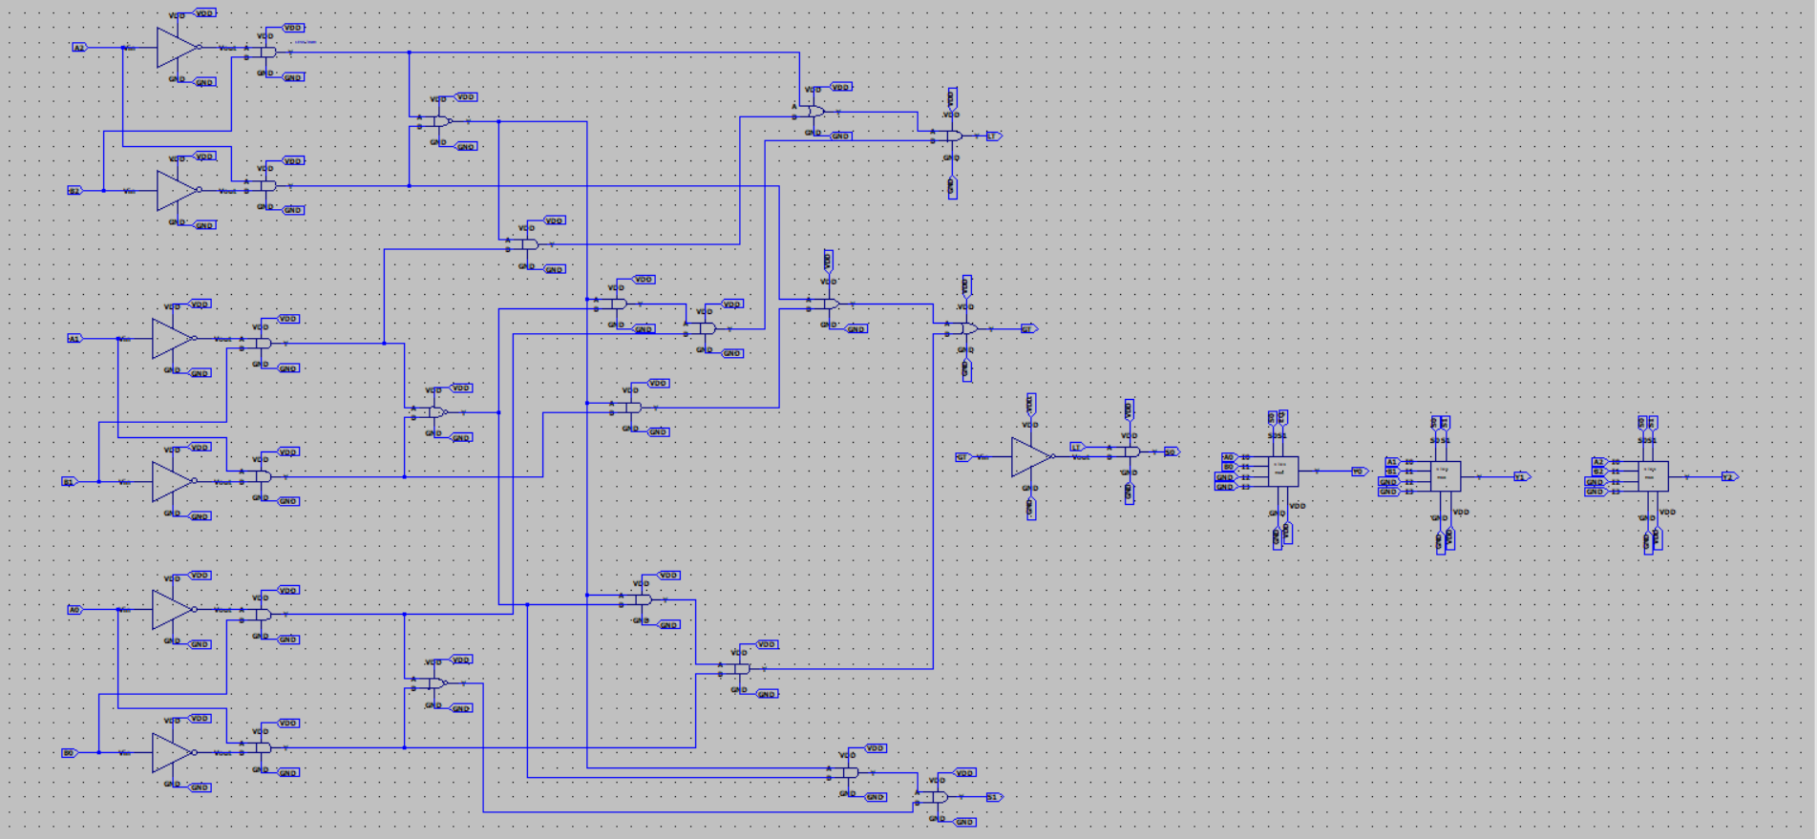

### Symbol

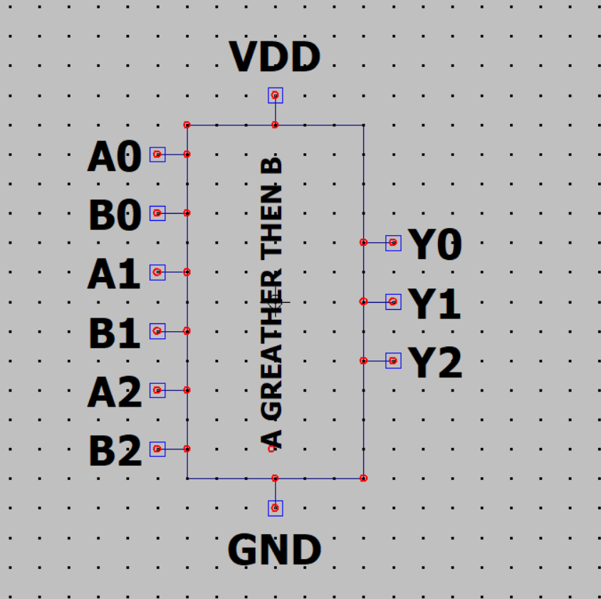

### Test case

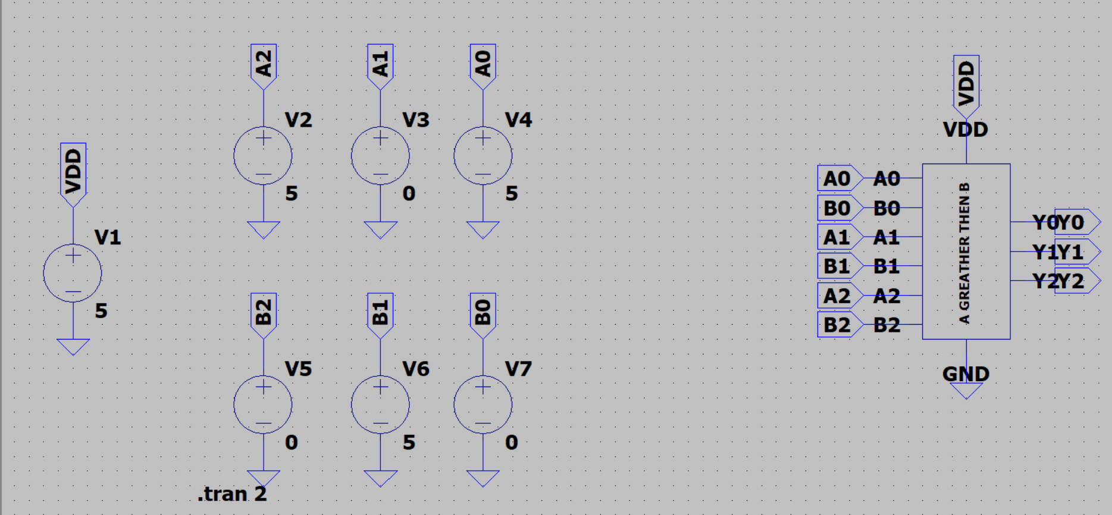

### Waveform1

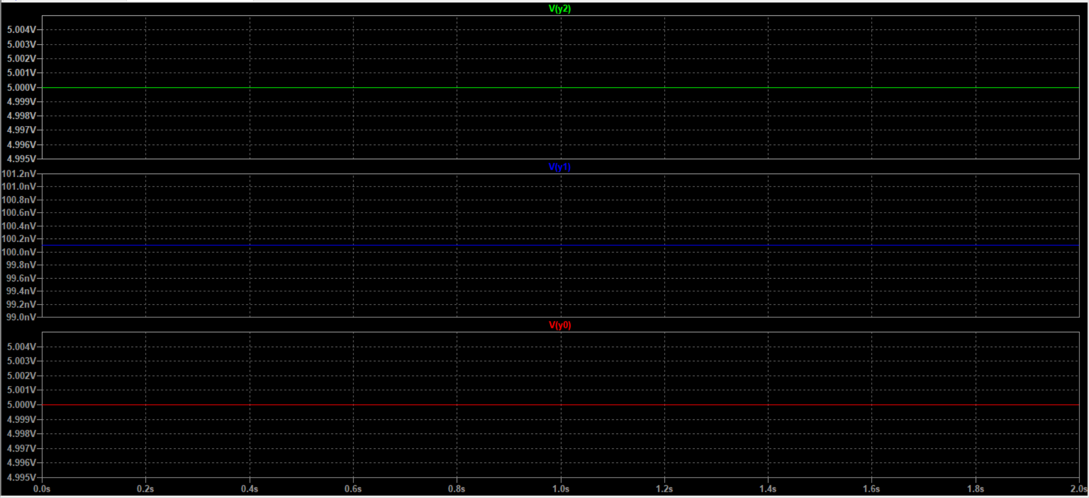

### Calculation1

|  |  |  |  |
| --- | --- | --- | --- |
|  | **INPUT** | | **OUTPUT** |
| **S.NO** | **A** | **B** | **y** |
| **1** | **101** | **010** | **101** |

### Conclusion

The output is perfectly matching with exact selection of operation from the truth table output and waveforms. So, the circuit is verified.

## Greaterthan Circuit with Enable.

### Gate Level Drawing

### Schematic

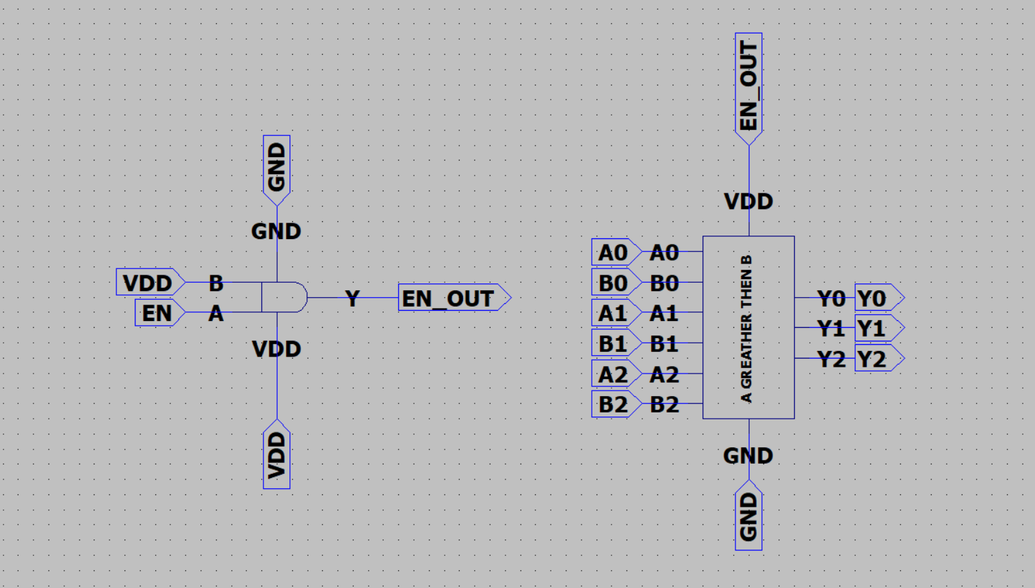

### Symbol

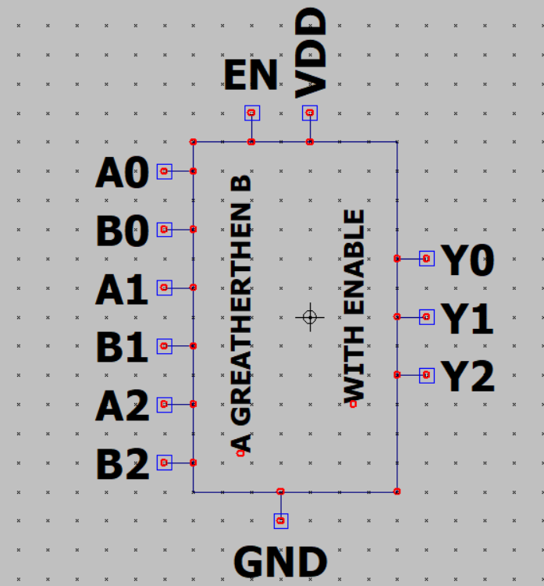

### Test case

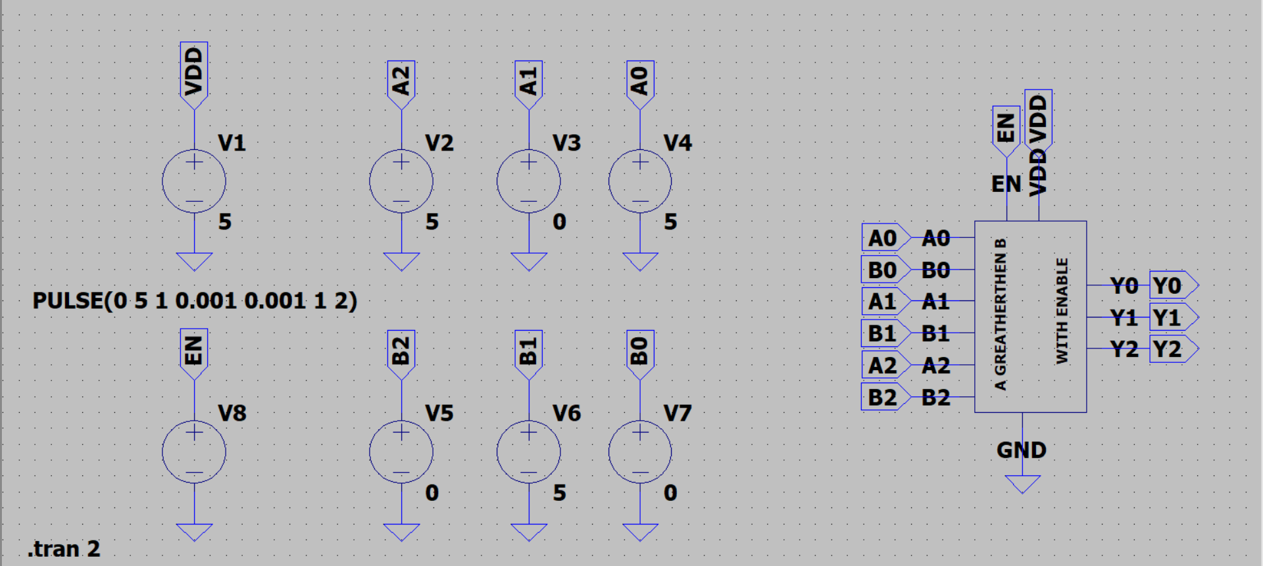

### Waveform

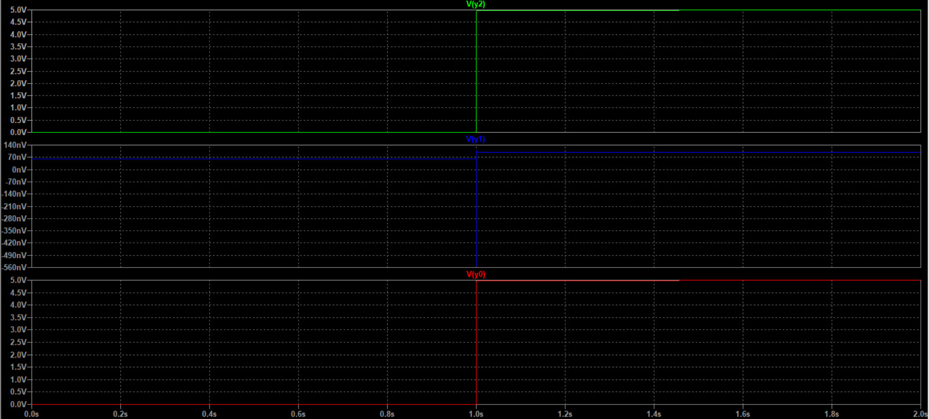

### Calculation

|  |  |  |  |  |
| --- | --- | --- | --- | --- |
|  |  | **INPUT** | | **OUTPUT** |
| **S.NO** | **EN** | **A** | **B** | **y** |
| **1** | **1** | **101** | **010** | **101** |

### Conclusion

The output is perfectly matching with exact selection of operation from the truth table output and waveforms. So, the circuit is verified.

## Athematic Shift Right Without Enable.

### Gate Level Drawing

### Schematic

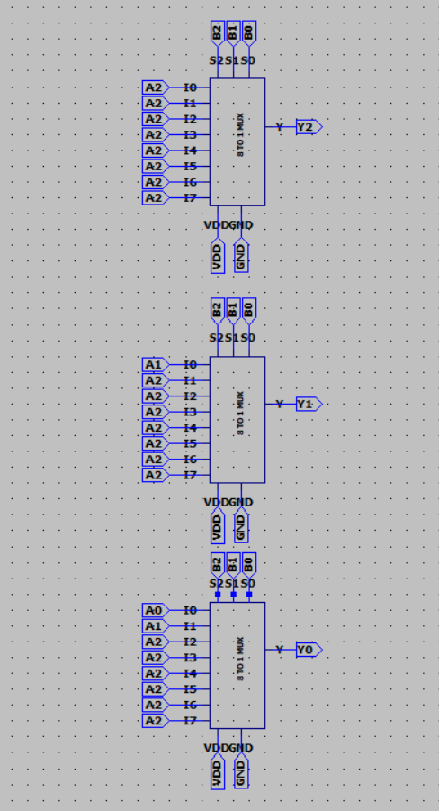

### Symbol

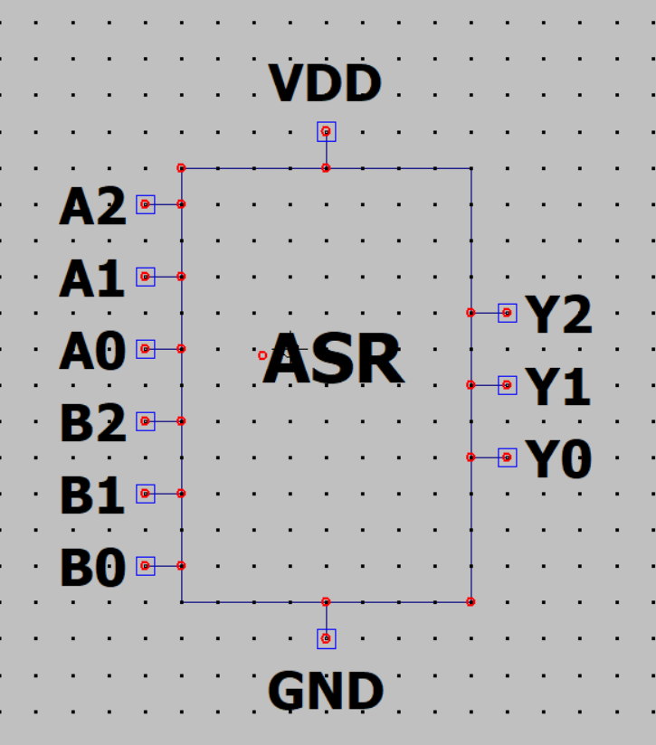

### Test case

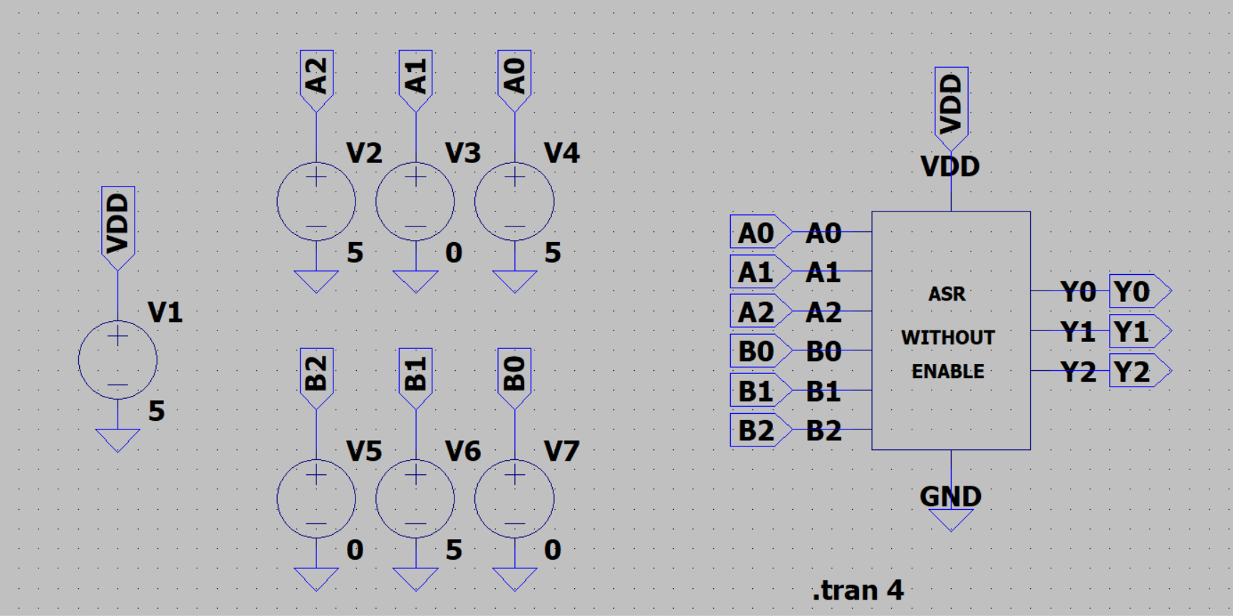

### Waveform

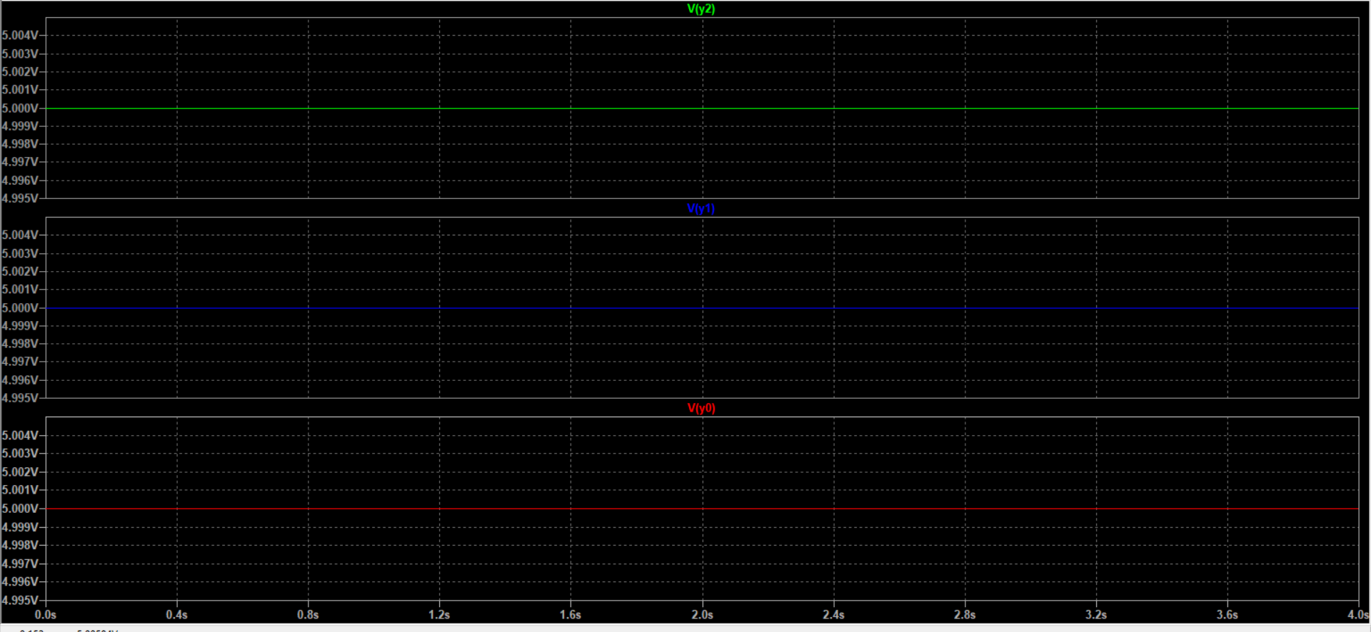

### Calculation

|  |  |  |  |
| --- | --- | --- | --- |
|  | **INPUT** | | **OUTPUT** |
| **S.NO** | **A** | **B** | **y** |
| **1** | **101** | **010** | **111** |

### Conclusion

The output is perfectly matching with exact selection of operation from the truth table output and waveforms. So, the circuit is verified.

## Athematic shift right with enable.

### Gate level drawing

## Schematic

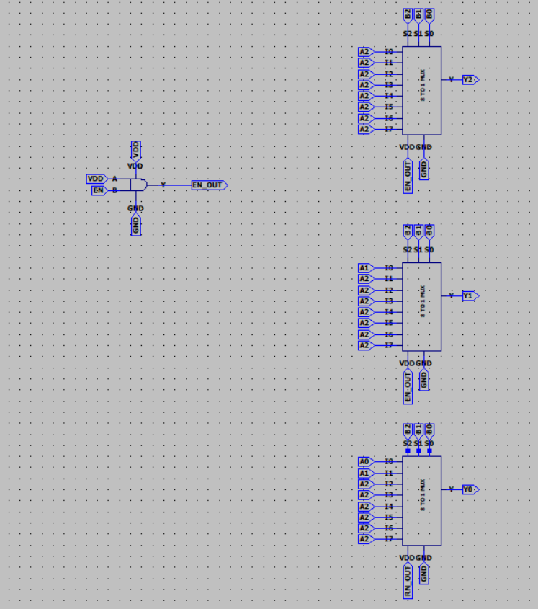

## Symbol

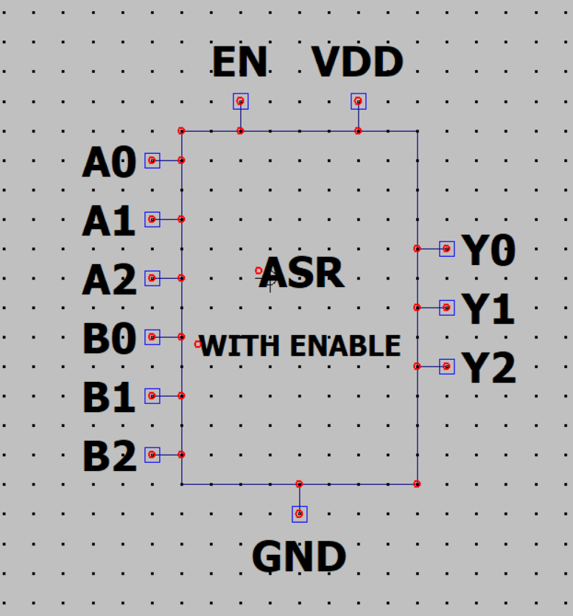

### Test case

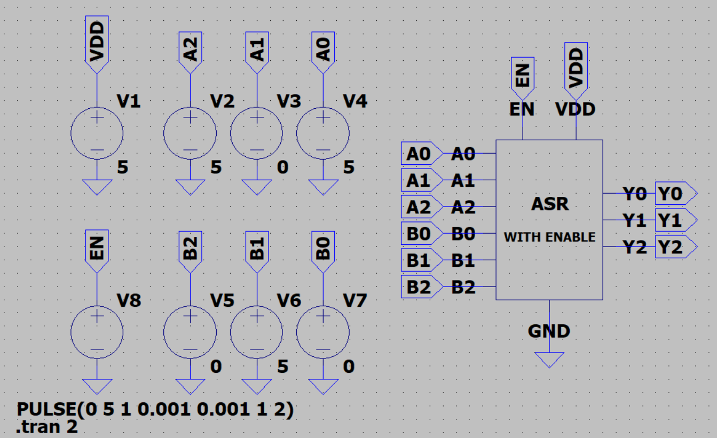

### Waveform1

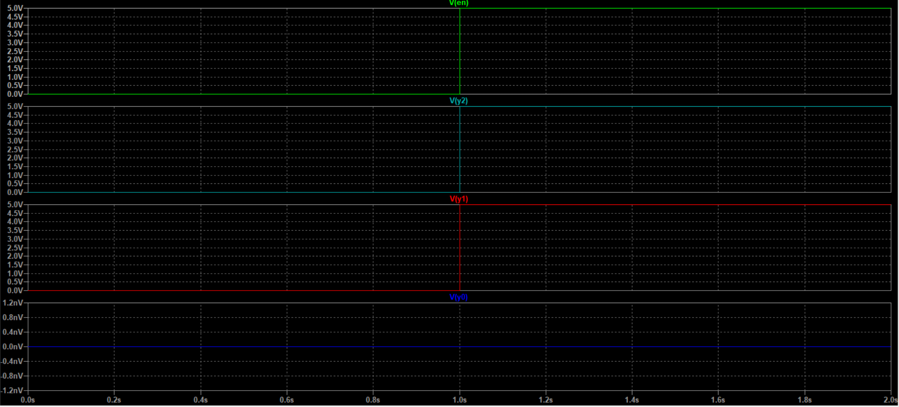

### Calculation

|  |  |  |  |  |  |  |  |  |  |  |  |  |  |  |  |  |  |  |
| --- | --- | --- | --- | --- | --- | --- | --- | --- | --- | --- | --- | --- | --- | --- | --- | --- | --- | --- |
| |  |  |  |  |  | | --- | --- | --- | --- | --- | |  |  | **INPUT** | | **OUTPUT** | | **S.NO** | **EN** | **A** | **B** | **y** | | **1** | **1** | **101** | **010** | **111** | |  |  |  |
|  |  |  |  |
|  |  |  |  |
|  |  |  |  |

## Conclusion

The output is perfectly matching with exact selection of operation from the truth table output and waveforms. So, the circuit is verified.

# Components

## 2 TO 1 MUX

### Gate level drawing

### Schematic

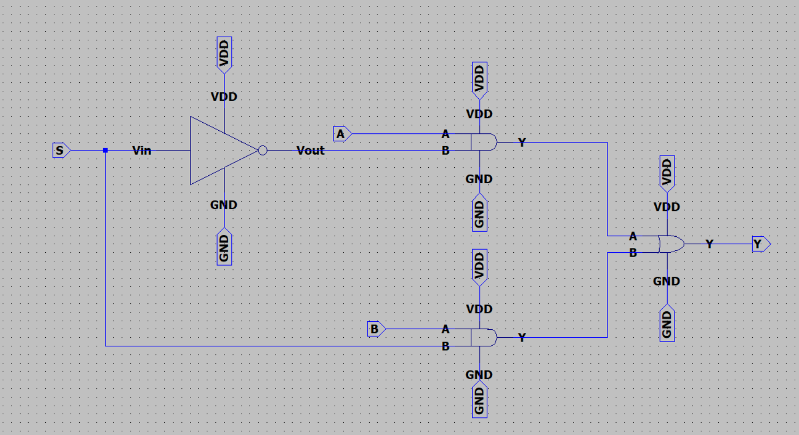

### Symbol

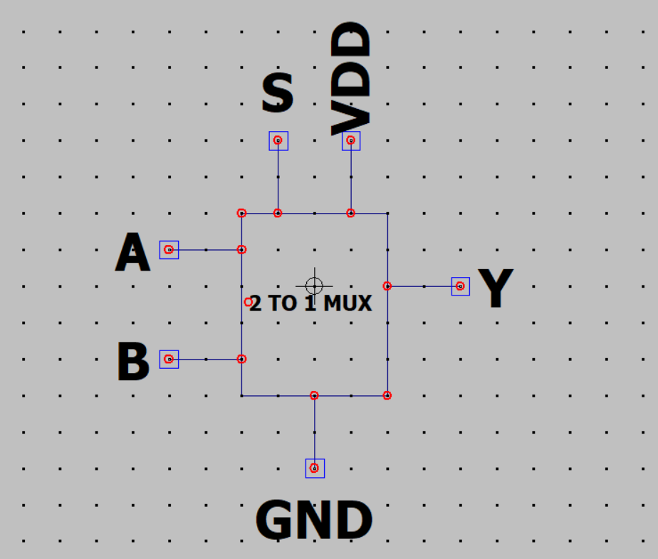

### Test

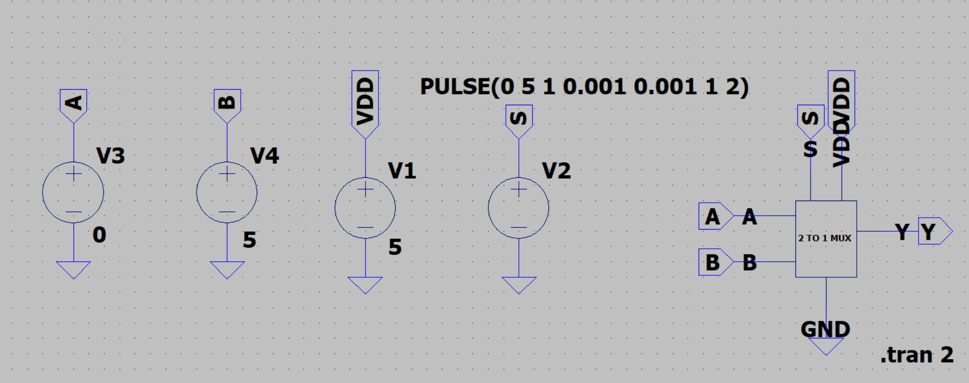

### Waveform

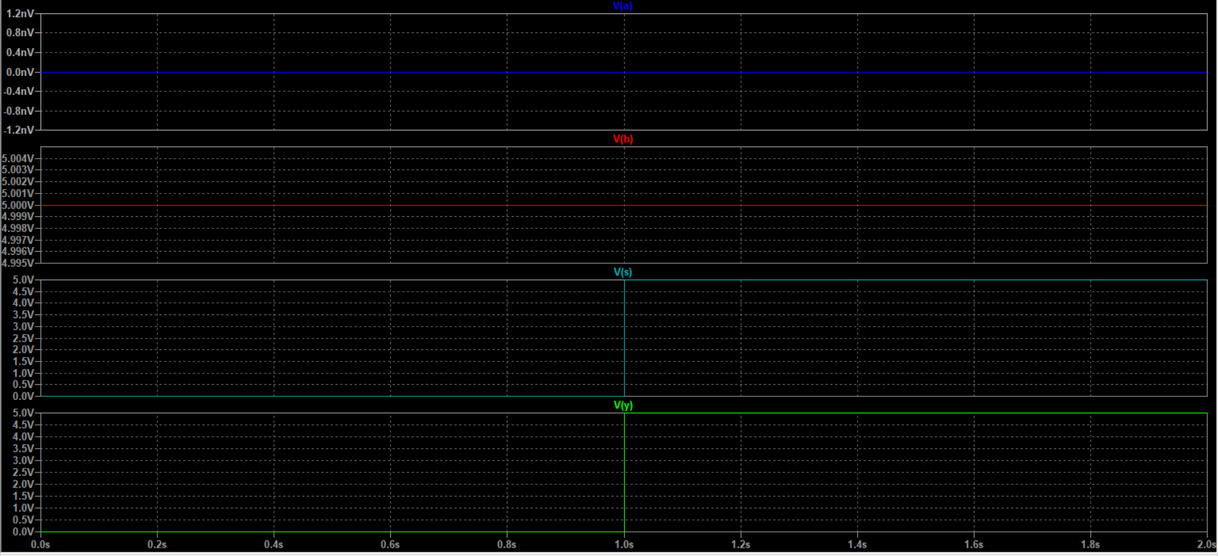

### Calculations/Truth table

|  |  |  |  |
| --- | --- | --- | --- |
| **S** | **A** | **B** | **Y** |
| **0** | **0** | **1** | **0** |
| **1** | **0** | **1** | **1** |

### Conclusion

## 4 TO 1 MUX

### Gate level drawing

### Schematic

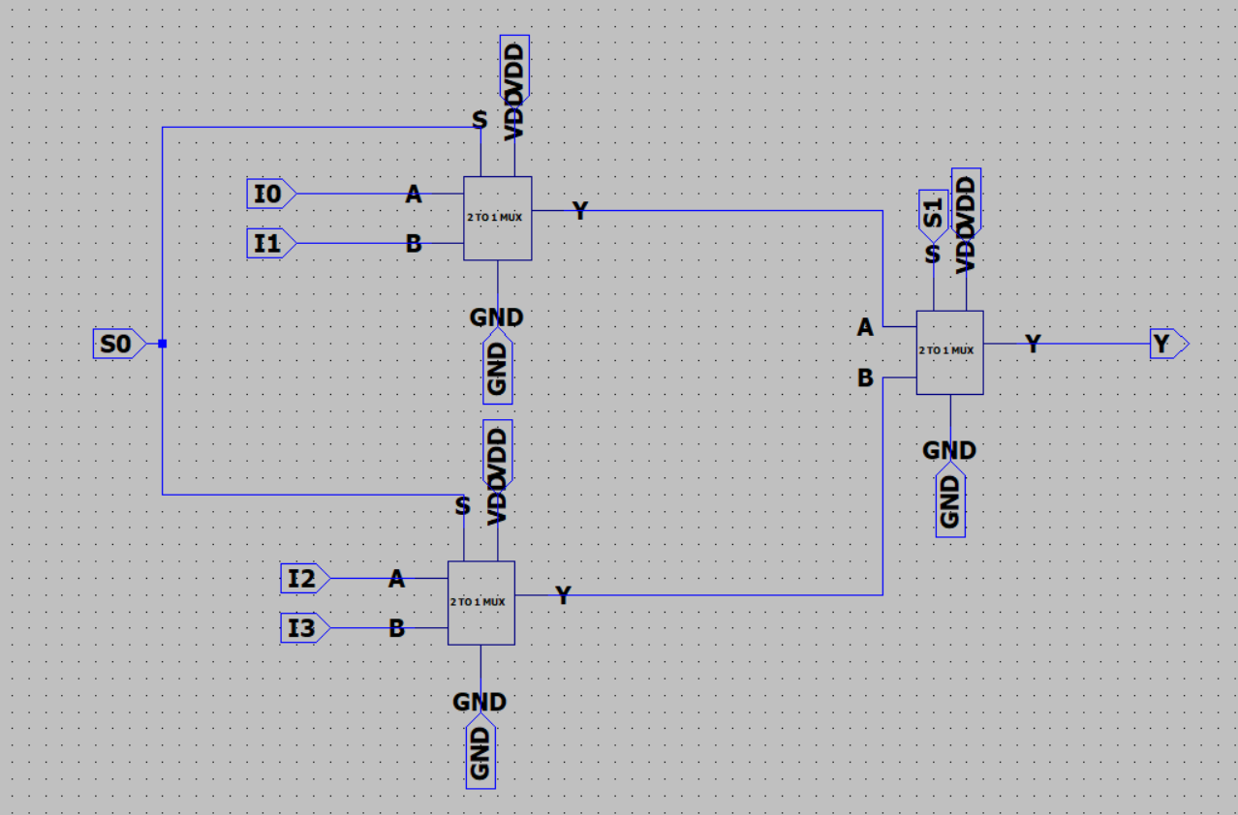

### Symbol

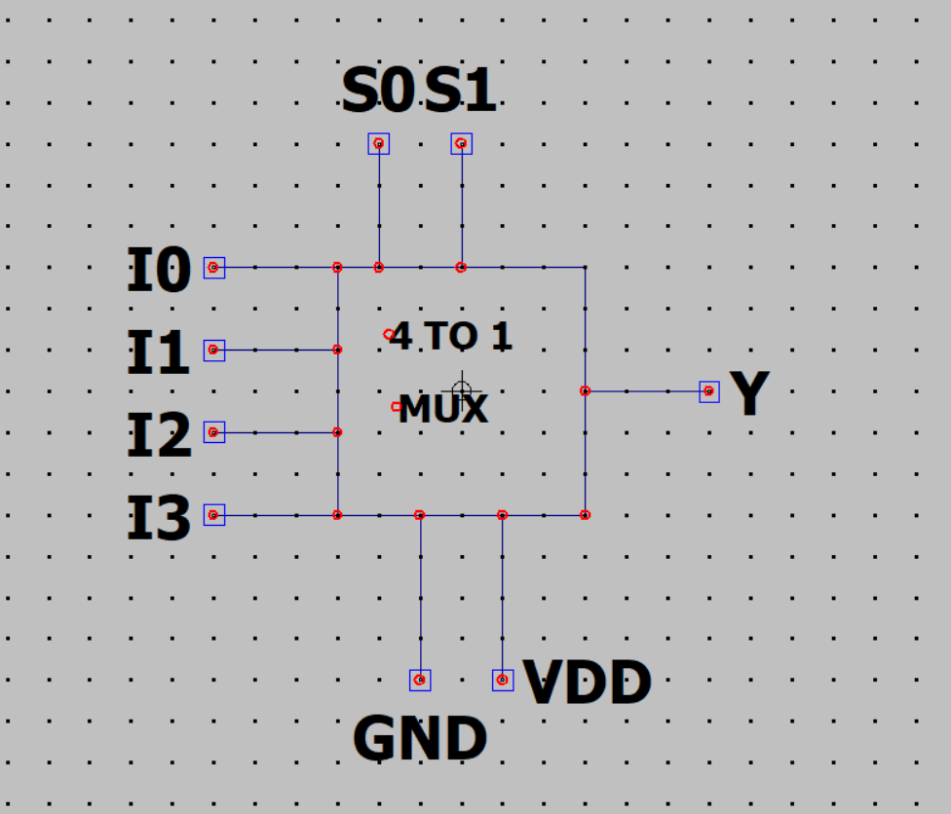

### Test

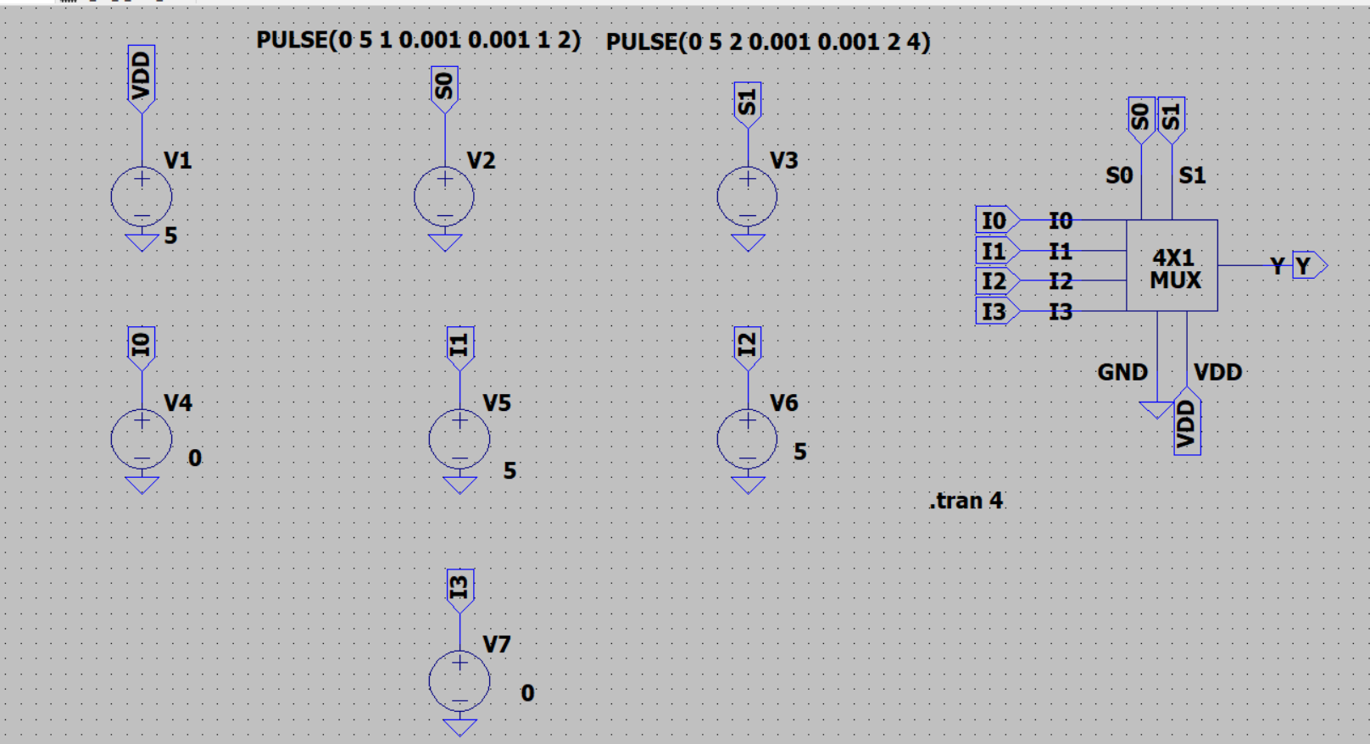

### Waveform

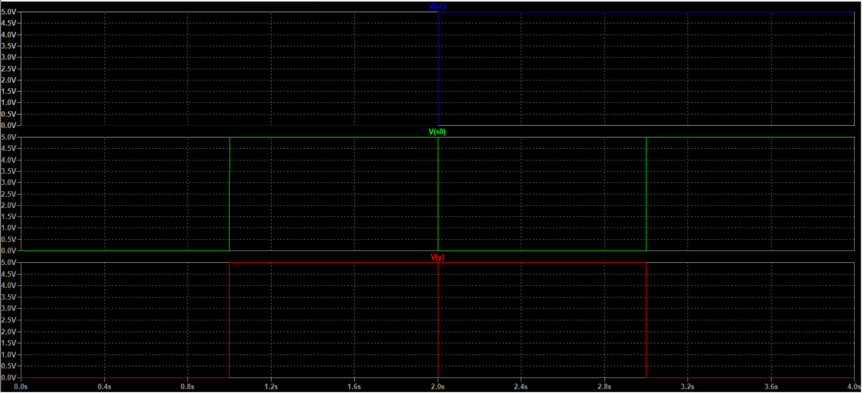

### Calculations/Truth table

|  |  |  |  |  |  |  |
| --- | --- | --- | --- | --- | --- | --- |
| **S1** | **S0** | **A** | **B** | **C** | **D** | **Y** |
| **0** | **0** | **0** | **1** | **1** | **0** | **0** |
| **0** | **1** | **0** | **1** | **1** | **0** | **1** |
| **1** | **0** | **0** | **1** | **1** | **0** | **1** |
| **1** | **1** | **0** | **1** | **1** | **0** | **0** |

### Conclusion

## 8 TO 1 MUX

### Gate level drawing

### Schematic

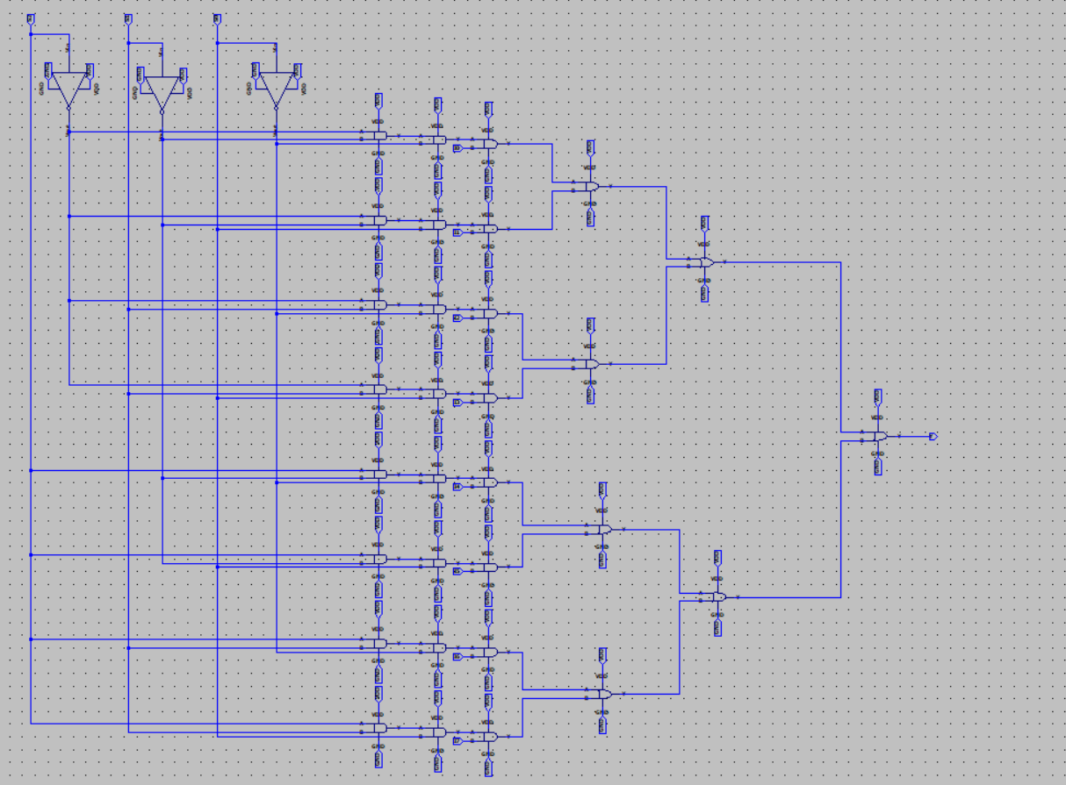

### Symbol

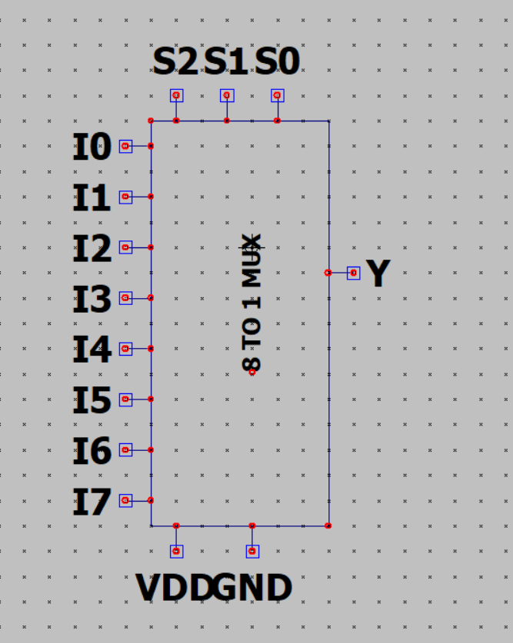

### Test

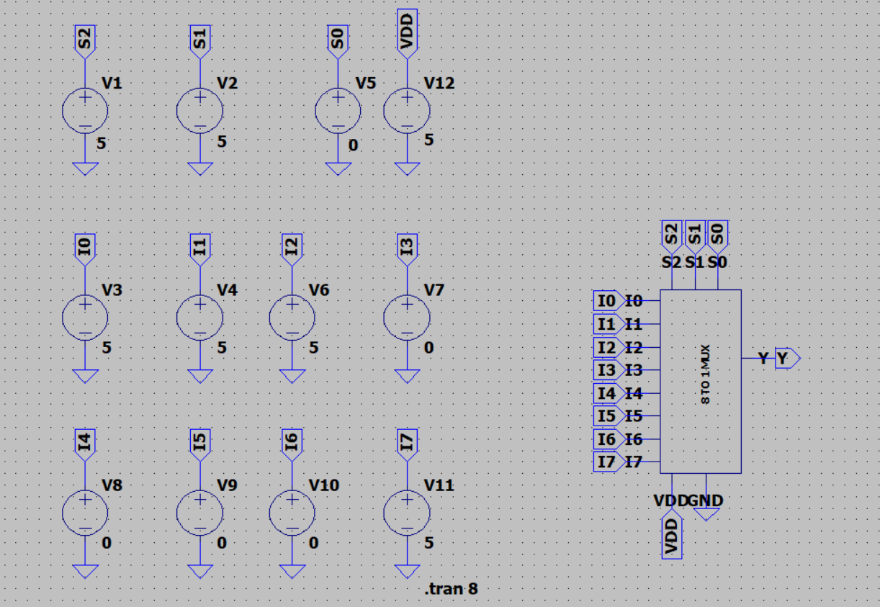

### Waveform

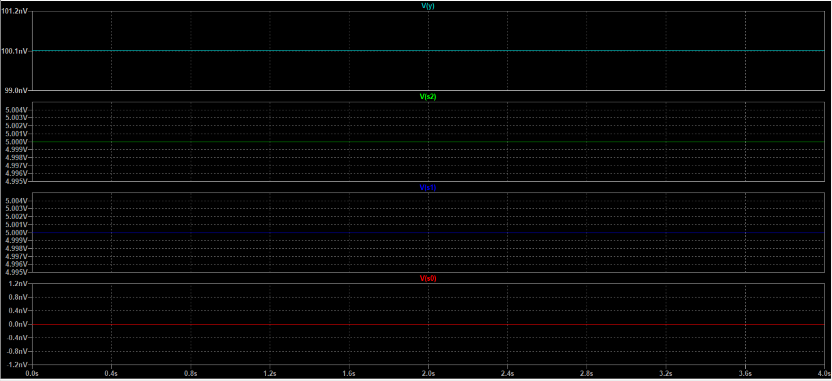

### Calculations/Truth table

### Conclusion

## Half adder

### Gate level drawing

### Schematic

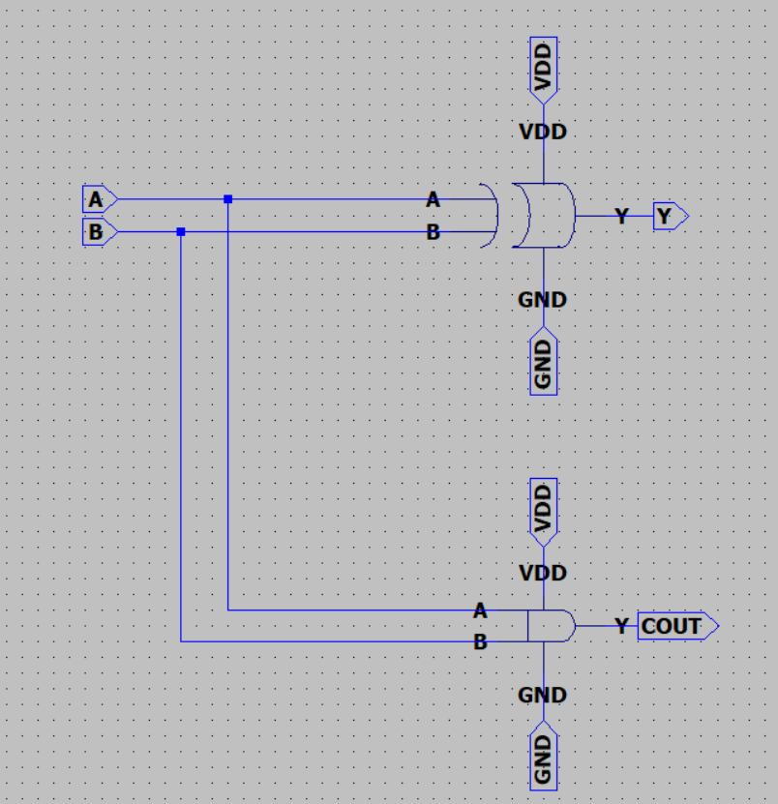

### Symbol

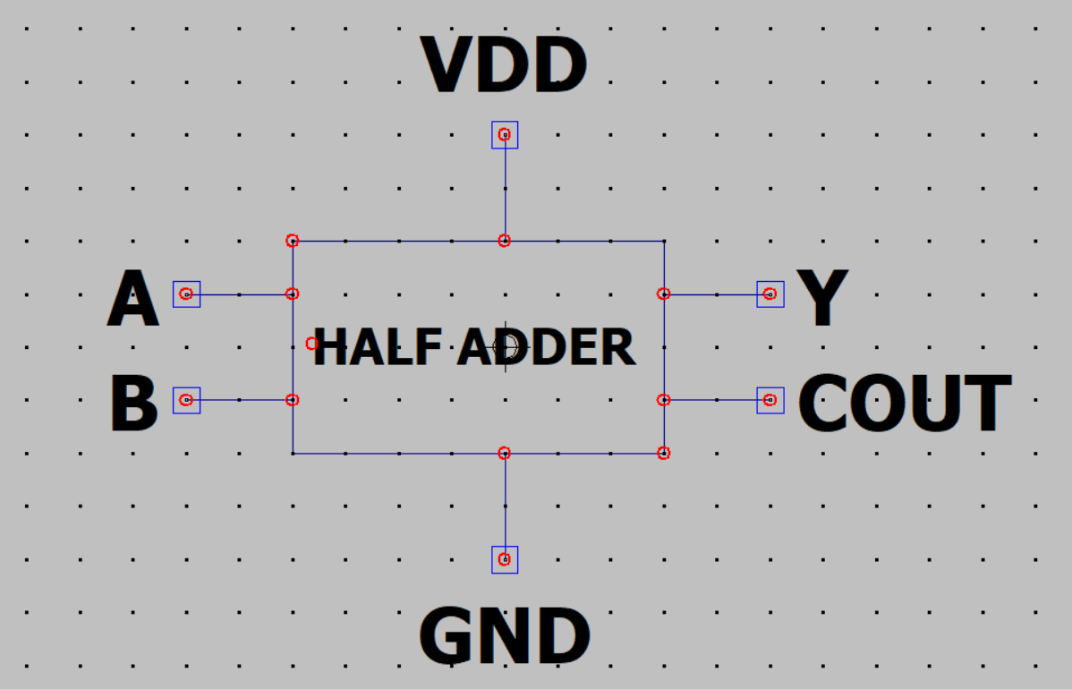

### Test

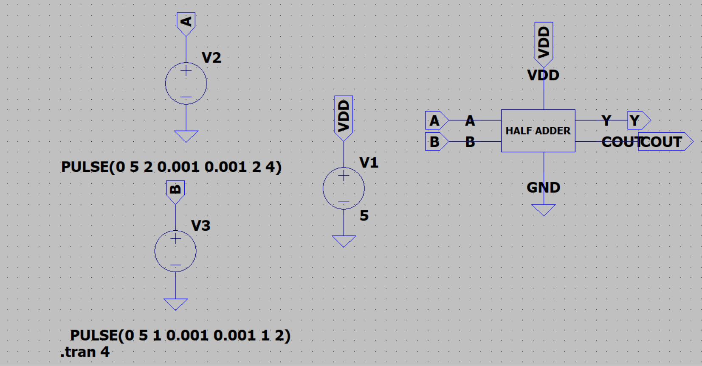

### Waveform

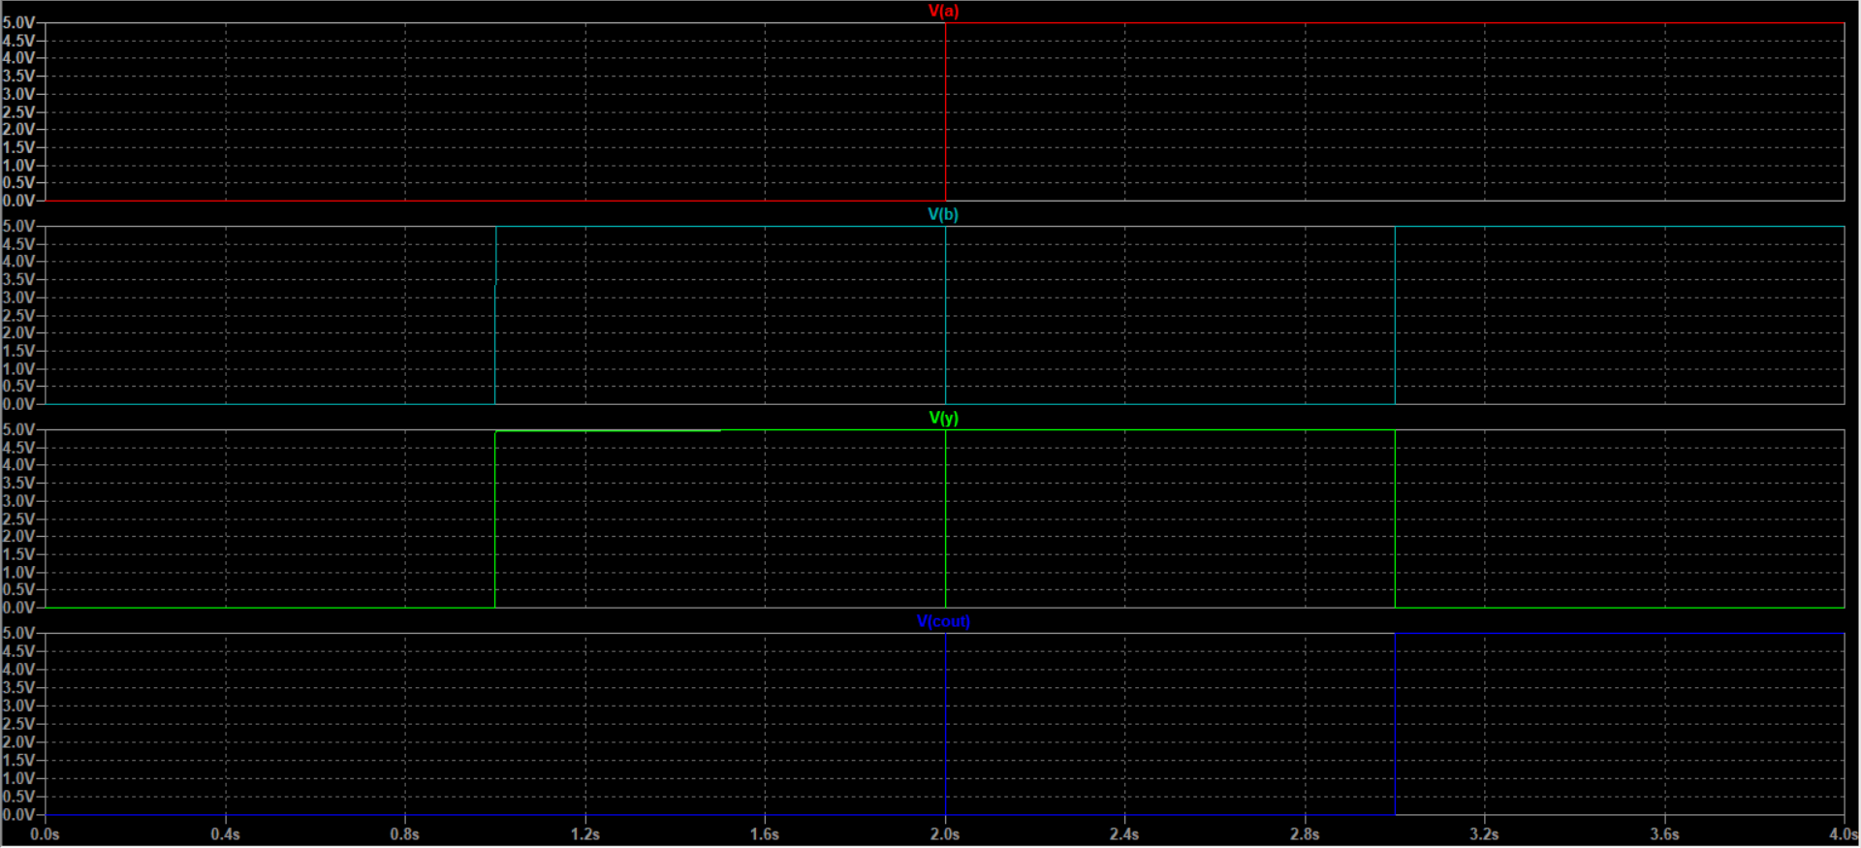

### Calculations/Truth table

|  |  |  |  |
| --- | --- | --- | --- |
| **A** | **B** | **Y** | **COUT** |
| **0** | **0** | **0** | **0** |
| **0** | **1** | **1** | **0** |
| **1** | **0** | **1** | **0** |
| **1** | **1** | **0** | **1** |

### Conclusion

## Full adder

### Gate level drawing

### Schematic

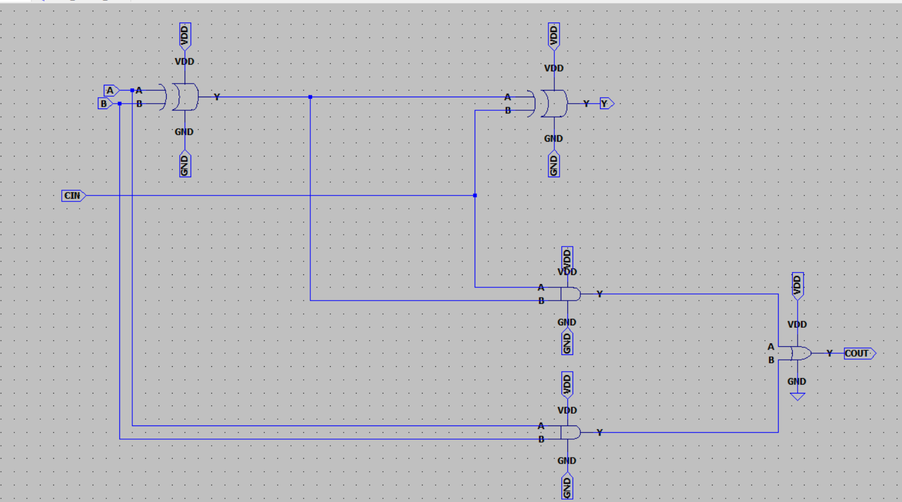

### Symbol

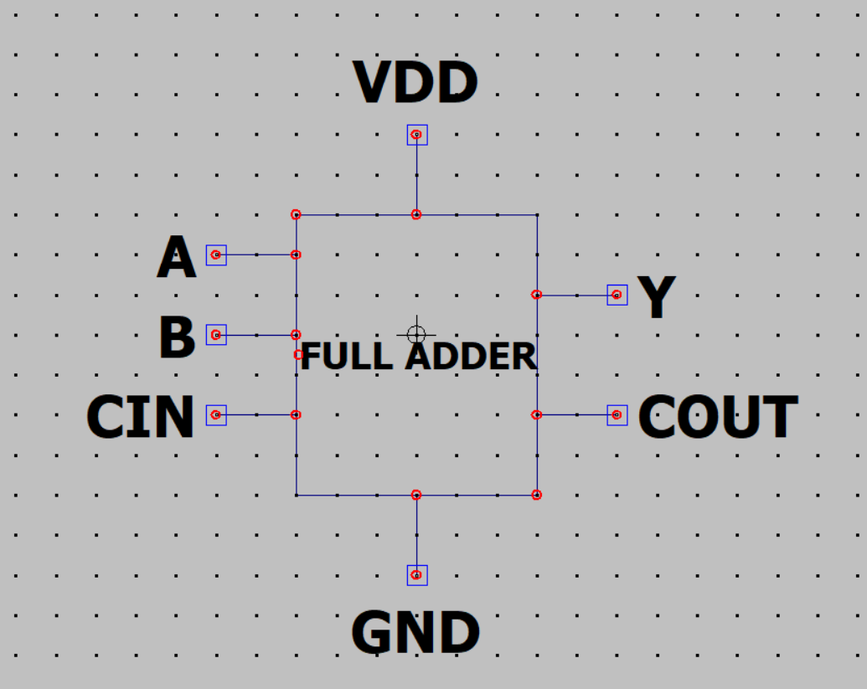

### Test

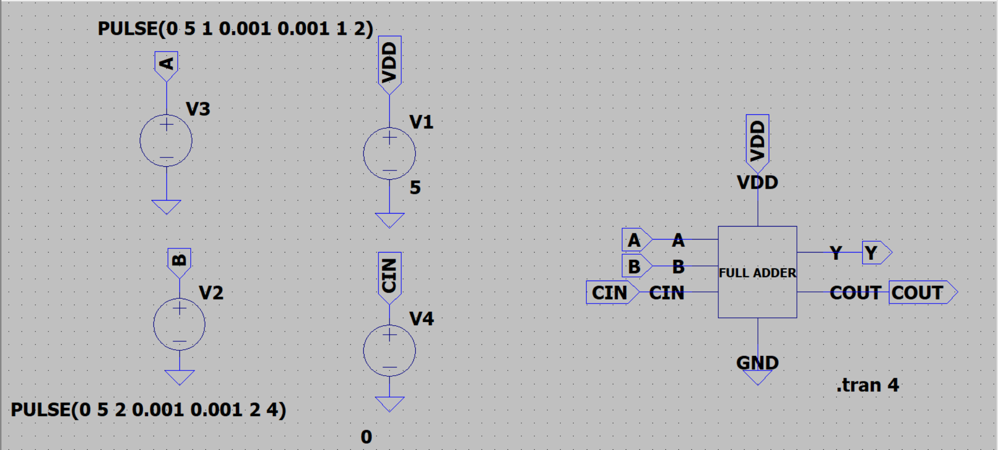

### Waveform

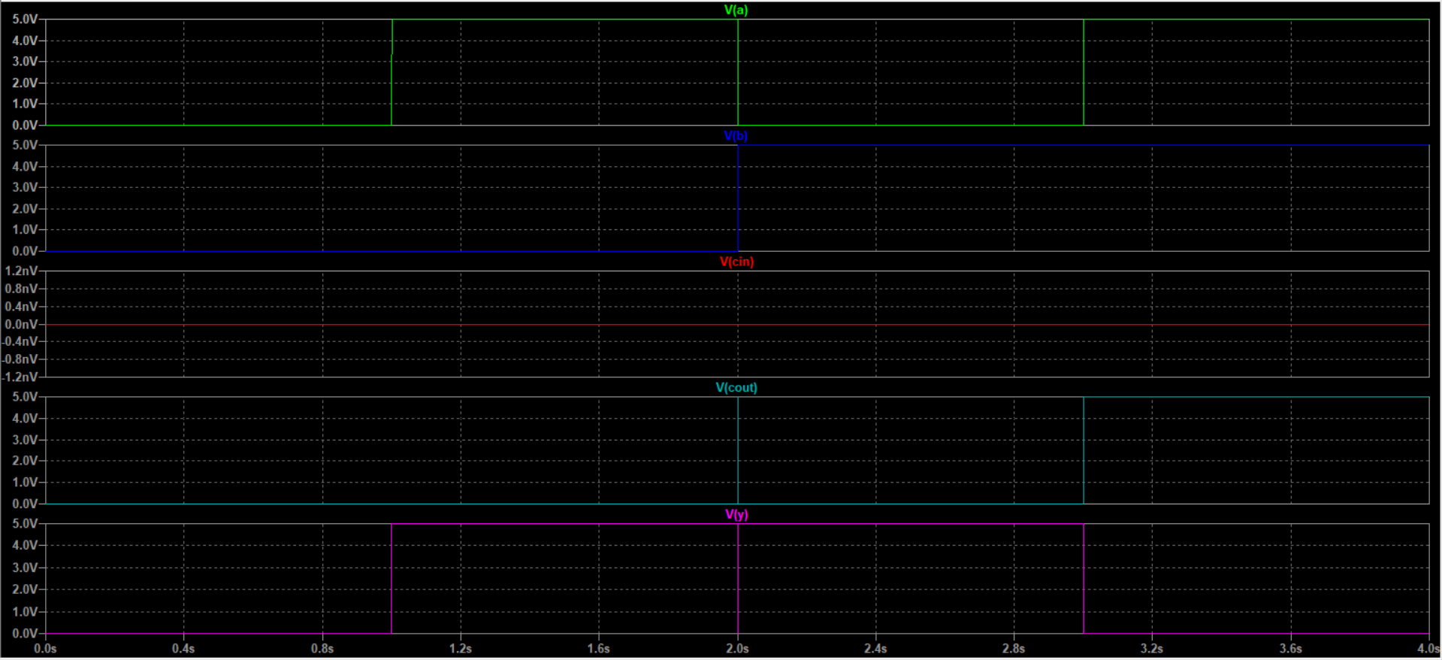

### Calculations/Truth table

|  |  |  |  |  |
| --- | --- | --- | --- | --- |
| **A** | **B** | **CIN** | **Y** | **COUT** |
| **0** | **0** | **0** | **0** | **0** |
| **0** | **1** | **0** | **1** | **0** |
| **1** | **0** | **0** | **1** | **0** |
| **1** | **1** | **0** | **0** | **1** |

### Conclusion

## 1 TO 2 DECODER

### Gate level drawing

### Schematic

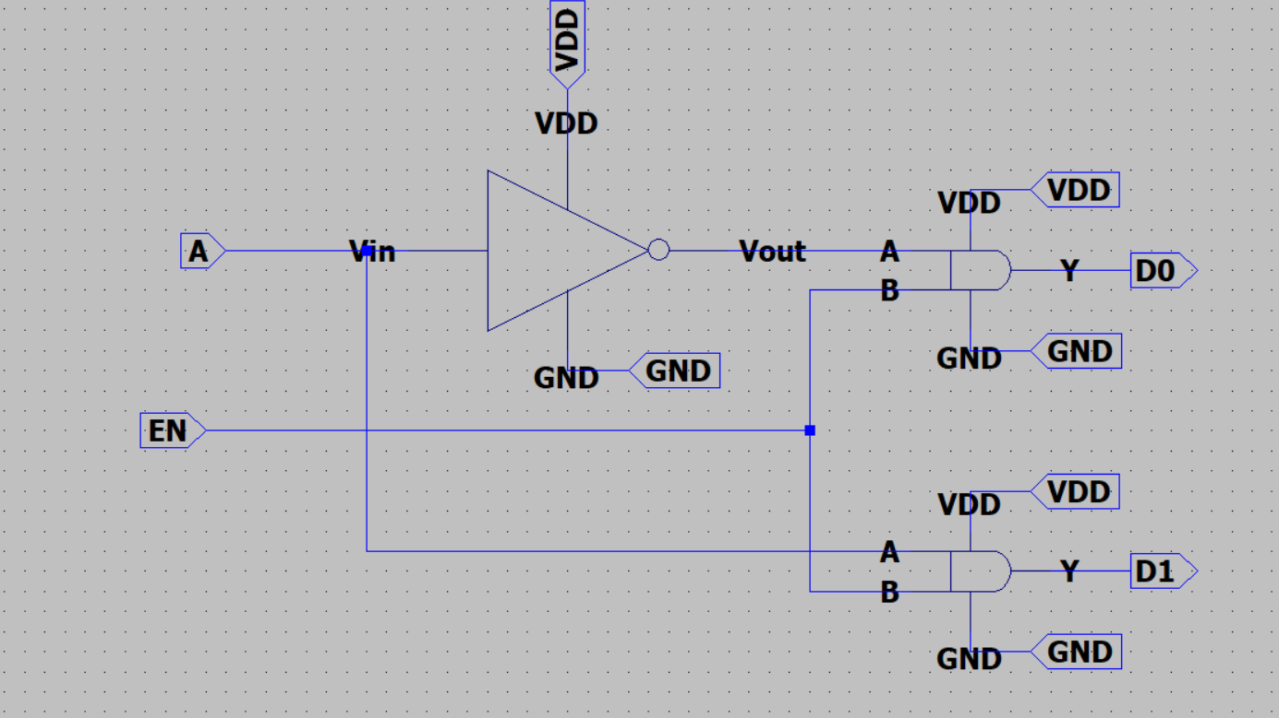

### Symbol

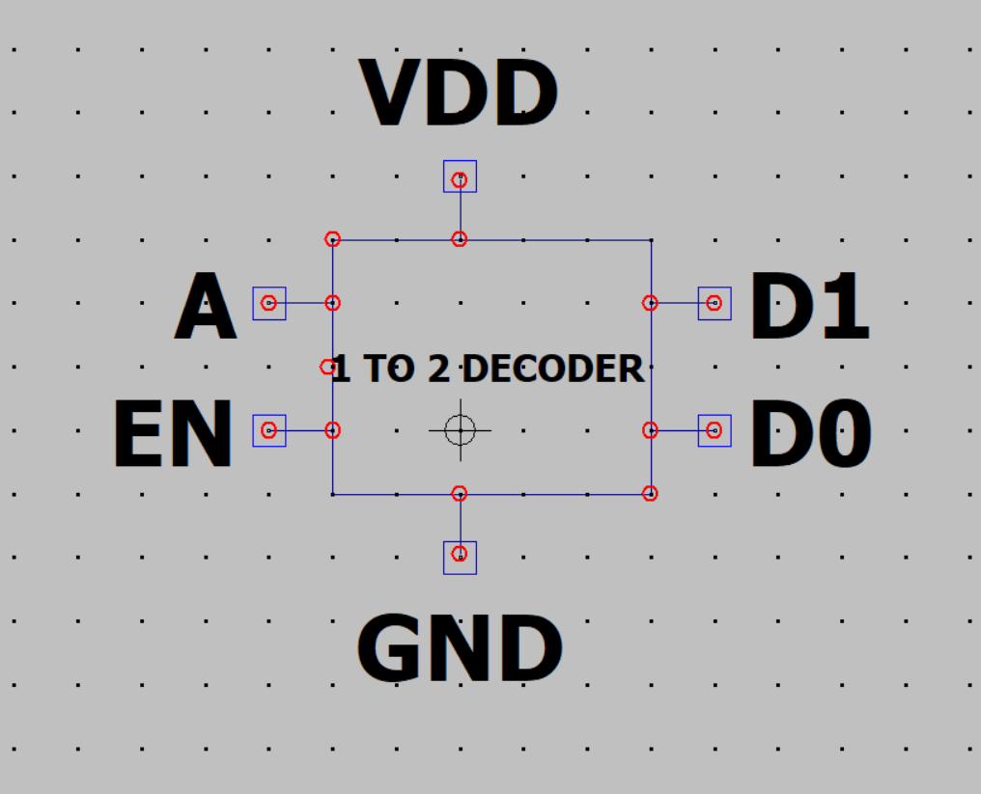

### Test

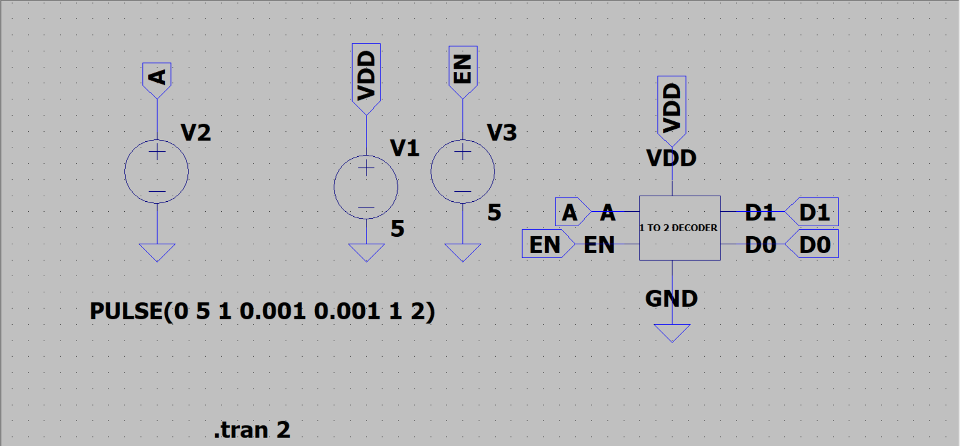

### Waveform

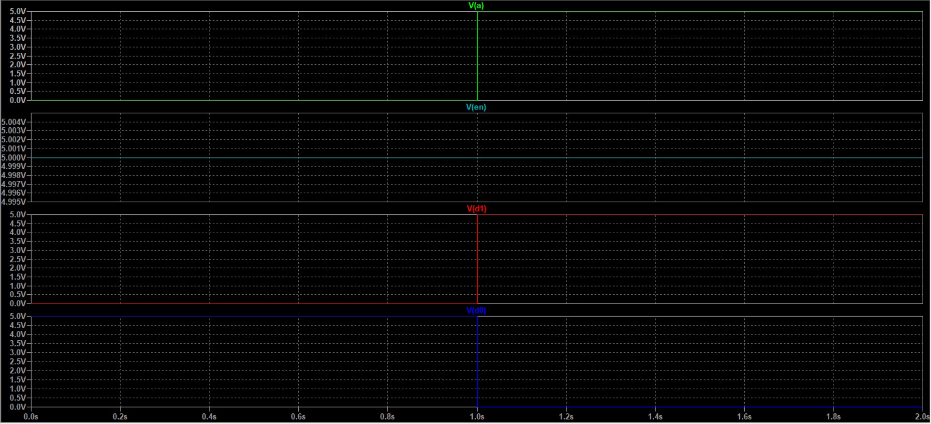

### Calculations/Truth table

|  |  |  |  |
| --- | --- | --- | --- |
| **EN** | **A** | **D1** | **D0** |
| **1** | **0** | **0** | **1** |
| **1** | **1** | **1** | **0** |

### Conclusion

## 2 TO 4 DECODER

### Gate level drawing

### Schematic

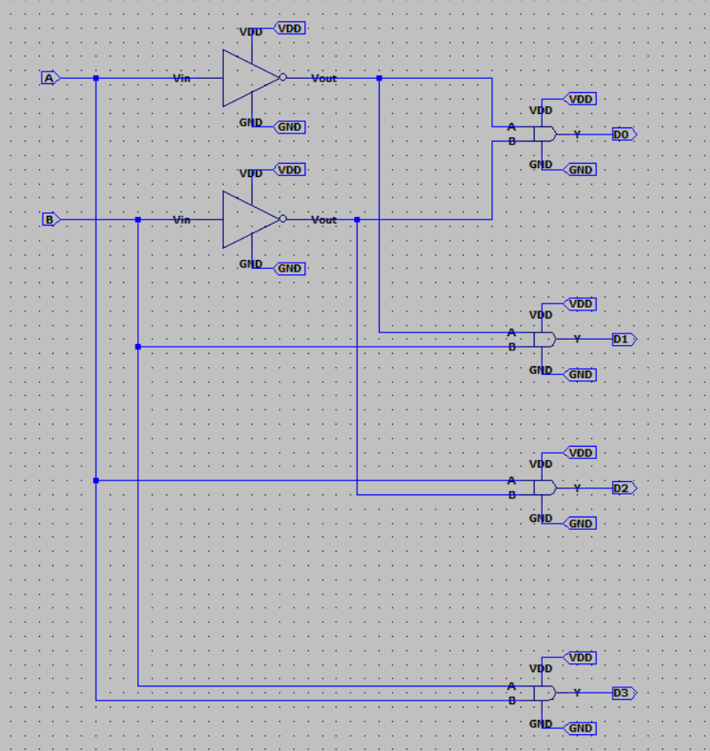

### Symbol

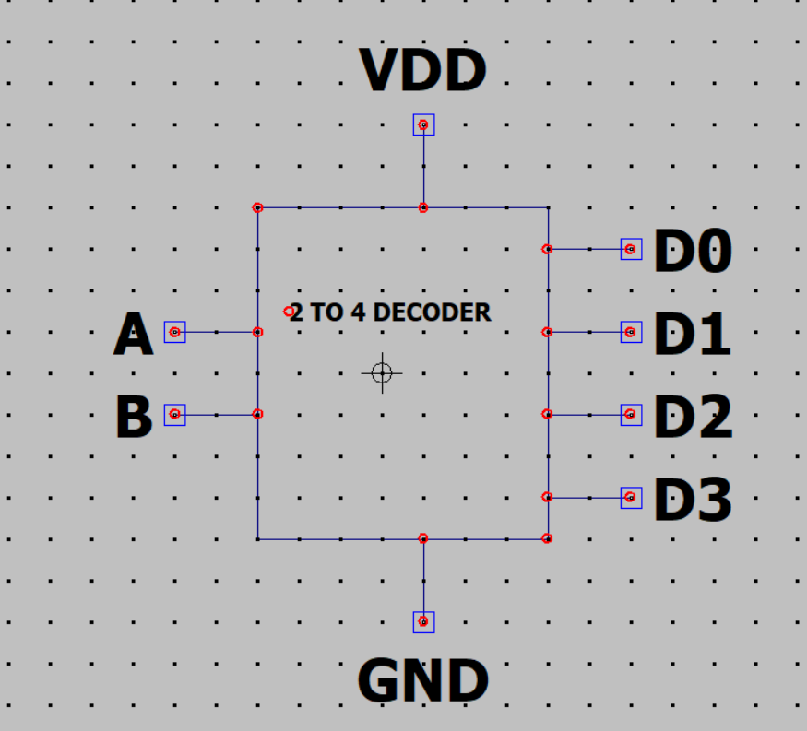

### Test

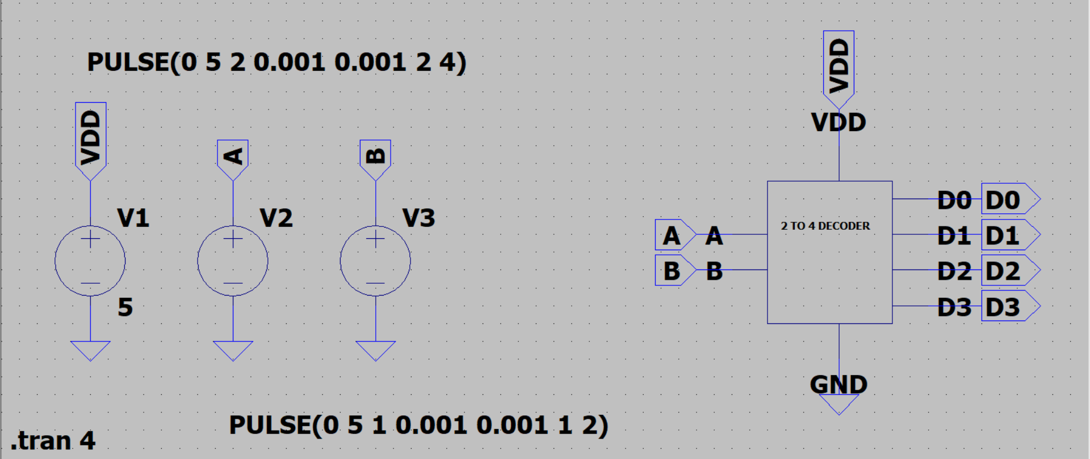

### Waveform

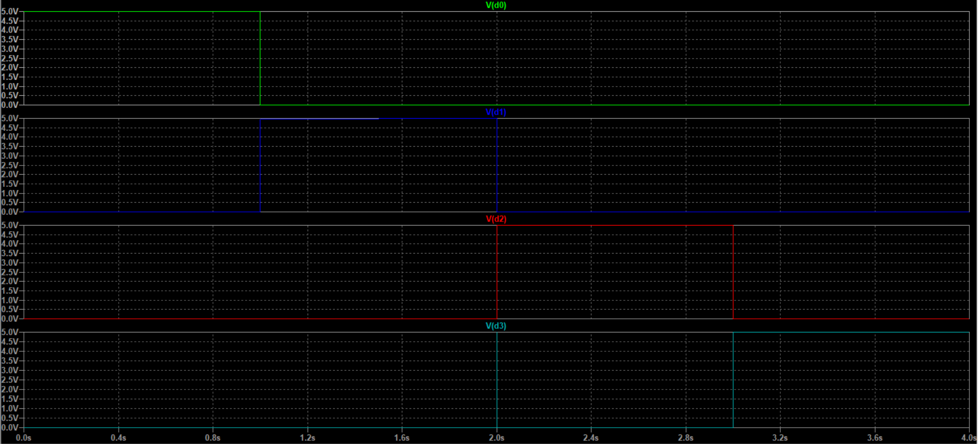

### Calculations/Truth table

|  |  |  |  |  |  |
| --- | --- | --- | --- | --- | --- |
| **A** | **B** | **D3** | **D2** | **D1** | **D0** |
| **0** | **0** | **0** | **0** | **0** | **1** |
| **0** | **1** | **0** | **0** | **1** | **0** |
| **1** | **0** | **0** | **1** | **0** | **0** |
| **1** | **1** | **1** | **0** | **0** | **0** |

### Conclusion

## 3 BIT 4 TO 1 MUX

### Gate level drawing

### Schematic

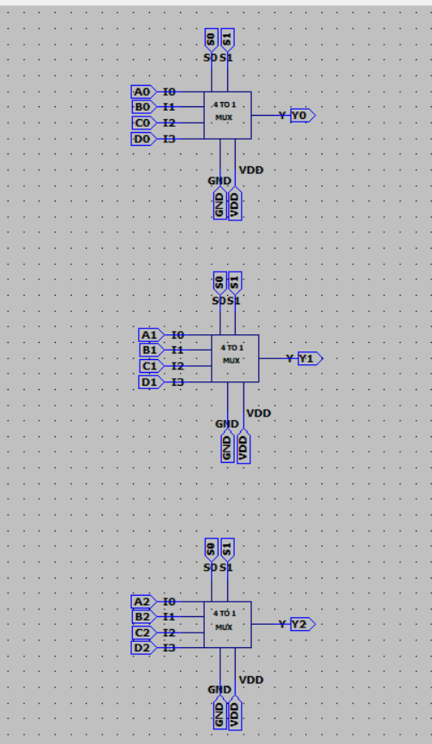

### Symbol

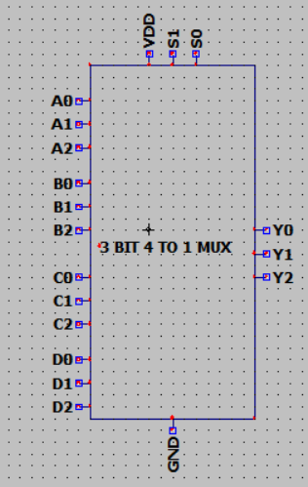

### Test case

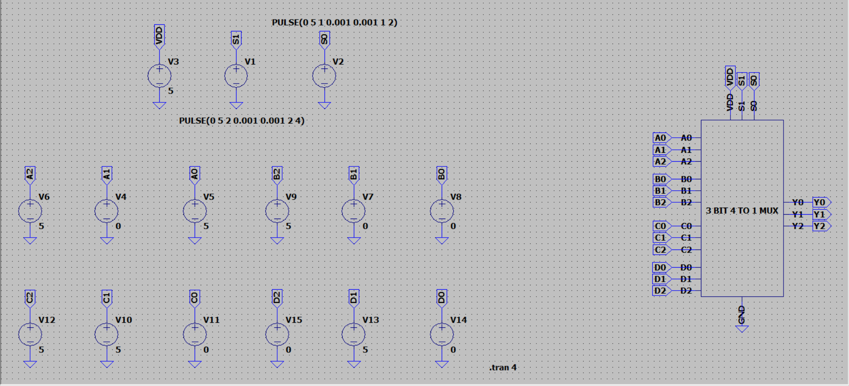

### Waveform

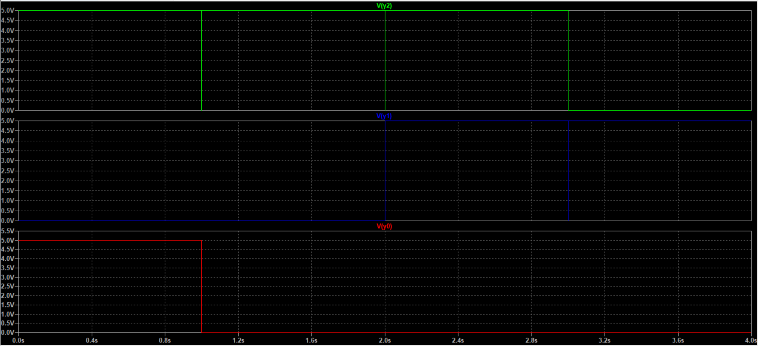

### Calculations/Truth table

### Conclusion